INDEX
TOPICS Page No’s

- Certificates
- Acknowledgement
- Abstract
- Figures/Tables

CHAPTER-1: INTRODUCTION 1
CHAPTER-2: LITERATURE SURVEY 2-4
CHAPTER-3: SYSTEM ANALYSIS
3.1 Existing System 5-6
3.2 Proposed System 6-8
CHAPTER-4: SYSTEM REQUIREMENTS
4.1 Hardware Requirements 9
4.2 Software Requirements 9-10
CHAPTER-5: SYSTEM STUDY
5.1 Feasibility Study 11
5.2 Feasibility Analysis 11-12
CHAPTER-6: SYSTEM ARCHITECTURE
6.1 ARCHITECTURE 13
6.2 UML Diagrams
6.2.1 Usecase Diagram 14-15
6.2.2 Class Diagram 16-17
6.2.3 Sequence Diagram 17-18
6.2.4 Collabration Diagram 18-19
6.2.5 Activity Diagram 19-21
6.2.6 Component Diagram 22
6.2.7 Deployment Diagram 23
6.2.8 ER Diagram 24
6.2.9 Data Dictionaries 24-31
CHAPTER-7: INPUT AND OUTPUT DESIGN
7.1 Input Design 32-33
7.2 Output Design 33
CHAPTER-8: IMPLEMENTATION
8.1 MODULES 34
8.1.1 Module Description 34-35
CHAPTER-9: SOFTWARE ENVIRONMENT
9.1 Python 36-59
9.2 Source Code 60-79
CHAPTER-10: RESULTS/DISCUSSIONS
10.1 System Test 80-83
10.2 Testcases 83-86
10.3 Output Screens 87-102
CHAPTER-11: CONCLUSION 103
CHAPTER-12: REFERENCES/BIBLIOGRAPHY 104-105

LIST OF FIGURES

LIST OF FIGURES

S.NO | TABLES/FIGURES | PAGE NO’S
1 | System Architecture | 13
2 | UML Diagrams | 13-31
 | 2.1 Use Case Diagram | 14-15
 | 2.2 Class Diagram | 16-17
 | 2.3 Sequence Diagram | 17-18
 | 2.4 Collaboration Diagram | 18-19
 | 2.5 Activity Diagram | 19-21
 | 2.6 Component Diagram | 22
 | 2.7 Deployment Diagram | 23
 | 2.8 ER Diagram | 24
 | 2.9 Data Dictionaries | 24-31
3 | About Java | 36-49
4 | Screenshots | 80-83

NeuroScan AI: An Explainable Deep Learning and RAG-Based Clinical Decision Support System for Multi-Class Brain MRI Diagnosis
ABSTRACT

Early detection of neurological disorders such as brain tumors and Alzheimer’s disease is crucial for effective treatment and patient care. However, manual analysis of MRI scans by radiologists can be time-consuming and subject to diagnostic variability. This project presents NeuroScan AI, an intelligent medical imaging platform designed to automatically analyze brain MRI scans using deep learning techniques. The system employs a Convolutional Neural Network (CNN) model to classify MRI images into three diagnostic categories: Brain Tumor, Alzheimer’s Disease, and Normal Anatomy.
To enhance interpretability and trust in the model’s predictions, the system integrates Grad-CAM visualization, which highlights the specific regions of the MRI scan that influenced the neural network’s decision. The platform is developed using the Django framework, providing secure user authentication, MRI upload functionality, and role-based dashboards for patients and clinicians. Patients can upload MRI scans through the patient portal, while medical professionals can review AI-generated predictions through an expert review interface.
Additionally, the system incorporates a Retrieval-Augmented Generation (RAG) module that retrieves relevant clinical knowledge and provides contextual medical insights related to the detected condition. The platform also supports automated report generation and expert validation to assist in clinical decision making. By combining deep learning, explainable AI, and medical knowledge retrieval, NeuroScan AI aims to improve the accuracy, interpretability, and efficiency of neurological disorder detection from MRI scans.

CHAPTER-1 INTRODUCTION
The rapid advancement of artificial intelligence has significantly transformed the healthcare industry, particularly in the field of medical image analysis. Brain-related diseases such as tumors and Alzheimer’s disease are among the most serious neurological conditions that require early and accurate diagnosis for effective treatment. Magnetic Resonance Imaging (MRI) is one of the most widely used medical imaging techniques for detecting abnormalities in the brain. However, analyzing MRI scans manually can be time-consuming and highly dependent on the expertise of radiologists.
In recent years, deep learning techniques have shown remarkable success in automatically analyzing medical images and assisting doctors in disease diagnosis. Convolutional Neural Networks (CNNs), in particular, have demonstrated high performance in image classification tasks due to their ability to extract complex patterns and features from medical images. By leveraging these techniques, automated systems can support medical professionals in identifying potential abnormalities quickly and accurately.
This project presents NeuroScan AI, an intelligent system designed to assist in the diagnosis of neurological conditions using brain MRI images. The system employs a deep learning model to classify MRI scans into three categories: Brain Tumor, Alzheimer’s Disease, and Normal Anatomy. This automated classification helps in providing early insights into possible neurological disorders.
To improve transparency and trust in the model’s predictions, the system integrates Explainable AI techniques such as Grad-CAM, which visually highlights the regions of the MRI scan that influenced the model’s decision. Additionally, the platform incorporates a Retrieval-Augmented Generation (RAG) module that retrieves relevant medical knowledge and presents contextual clinical insights related to the predicted condition.
The entire system is implemented using the Django web framework, providing features such as user authentication, MRI image upload, patient dashboards, and expert review interfaces. Patients can upload MRI scans for analysis, while clinicians can review the AI-generated predictions and generate diagnostic reports.
By combining deep learning, explainable AI, and clinical knowledge retrieval, NeuroScan AI aims to provide a supportive decision-making tool for medical professionals, improving diagnostic efficiency and assisting in the early detection of neurological disorders.
Furthermore, the system also includes an automated reporting mechanism that summarizes the AI analysis along with relevant clinical insights. This feature helps clinicians quickly understand the diagnostic outcome and supports them in making informed medical decisions. The integration of advanced AI models with a user-friendly web interface ensures that the platform can be easily used in real-world healthcare environments. By reducing the time required for manual MRI analysis, the system aims to improve the efficiency of the diagnostic process. Ultimately, NeuroScan AI contributes toward the development of intelligent healthcare systems that assist doctors in delivering faster and more accurate neurological diagnoses.

.

CHAPTER-2 LITERATURE SURVEY
Title: “Brain Tumor Detection Using Convolutional Neural Networks”
Abstract:
This research focuses on the application of deep learning techniques for detecting brain tumors from MRI images. The study utilizes Convolutional Neural Networks (CNN) to automatically extract important features from brain MRI scans and classify them into tumor and non-tumor categories. MRI images are preprocessed using normalization and noise reduction techniques to improve model performance. The CNN architecture is trained on a labeled dataset containing different brain MRI samples. Experimental results show that deep learning models significantly improve classification accuracy compared to traditional machine learning approaches. The proposed system helps radiologists detect tumors faster and reduces the possibility of human errors during diagnosis. The study highlights the potential of deep learning in assisting medical professionals in neurological disease detection.

Title: “Deep Learning-Based Alzheimer’s Disease Classification Using MRI Images”
Abstract:
This paper presents a deep learning approach for the early detection of Alzheimer’s disease using brain MRI images. Alzheimer’s disease is a progressive neurological disorder that affects memory and cognitive functions. The proposed system uses Convolutional Neural Networks to automatically extract structural features from MRI images of the brain. Image preprocessing techniques such as resizing, normalization, and noise filtering are applied before training the model. The system classifies MRI scans into Alzheimer’s affected and healthy brain categories. Experimental results demonstrate that deep learning models can effectively identify subtle changes in brain structure associated with Alzheimer’s disease. The research emphasizes the importance of AI-based medical imaging systems in improving early diagnosis and assisting clinicians in treatment planning.

Title: “Explainable Artificial Intelligence for Medical Image Analysis Using Grad-CAM”
Abstract:
This study focuses on improving transparency and interpretability in deep learning models used for medical image classification. While deep learning models achieve high accuracy, they often behave as black-box systems, making it difficult for clinicians to understand the reasoning behind predictions. The paper introduces the use of Grad-CAM (Gradient-weighted Class Activation Mapping) as an explainable AI technique. Grad-CAM highlights the regions of an image that contribute most to the model’s prediction. In medical imaging applications, this visualization helps doctors verify whether the model is focusing on clinically relevant regions. The proposed method improves trust in AI systems and allows clinicians to interpret predictions more effectively.

Title: “A Retrieval-Augmented Generation Framework for Clinical Decision Support”
Abstract:
This research explores the use of Retrieval-Augmented Generation (RAG) models for improving clinical decision support systems. The RAG framework combines information retrieval with generative language models to provide context-aware responses. In healthcare applications, the system retrieves relevant medical knowledge from clinical databases and generates meaningful explanations for disease diagnosis. This approach helps medical professionals access reliable clinical information quickly and supports evidence-based decision making. The study demonstrates that integrating RAG with AI diagnostic systems improves the quality of medical insights and enhances the interpretability of AI-generated predictions.

Title: “Web-Based Medical Image Analysis Systems Using the Django Framework”
Abstract:
This paper presents the development of web-based medical imaging systems using modern web frameworks such as Django. The proposed system enables patients and clinicians to upload medical images through a secure web interface. The backend processes the images using machine learning models and returns diagnostic results to users. The system includes user authentication, patient dashboards, and expert review interfaces. Django provides a scalable and secure environment for handling medical data and managing user interactions. The study highlights how web technologies can be combined with AI models to build practical healthcare solutions accessible from anywhere through the internet.

Title: “Multi-Class Brain MRI Classification Using Deep Learning Techniques”
Abstract:
This study investigates the use of deep learning models for multi-class classification of brain MRI images. The system is designed to identify multiple neurological conditions, including brain tumors, Alzheimer’s disease, and normal brain anatomy. Convolutional Neural Networks are used to automatically learn complex features from MRI images without manual feature extraction. The dataset is preprocessed and divided into training and testing sets to evaluate model performance. Experimental results show that deep learning-based multi-class classifiers achieve high accuracy in identifying different brain conditions. The proposed approach demonstrates the effectiveness of AI in supporting medical diagnosis and improving healthcare decision-making.
.

CHAPTER-3 SYSTEM ANALYSIS

EXISTING SYSTEM

The existing systems for brain disease detection mainly rely on manual examination of MRI scans performed by experienced radiologists. In traditional medical workflows, doctors visually inspect MRI images to identify abnormalities such as tumors, neurodegenerative diseases, or structural changes in the brain. This process requires significant expertise and can be time-consuming, especially when dealing with a large number of medical images. Although modern hospitals use digital imaging systems to store and display MRI scans, the diagnostic process still heavily depends on human interpretation.
Some existing systems incorporate basic computer-aided diagnosis tools that assist doctors by highlighting suspicious regions in MRI images. However, many of these systems are limited to detecting a single disease such as brain tumors and often lack the capability to classify multiple neurological conditions simultaneously. Additionally, most conventional systems function as black-box models, providing predictions without explaining how the decision was made. This lack of interpretability can reduce trust among medical professionals when relying on automated predictions.
Furthermore, existing solutions often lack integration with web-based platforms that allow patients and clinicians to easily upload MRI scans and access results remotely. In many cases, medical imaging analysis is performed offline using specialized software, which limits accessibility and scalability. Due to these limitations, there is a growing need for intelligent systems that combine automated disease detection, explainable AI techniques, and user-friendly platforms to assist healthcare professionals in diagnosing neurological disorders more efficiently.
.

DISADVANTAGES
Manual MRI analysis requires highly skilled radiologists and significant time to interpret medical images accurately, which may delay diagnosis and treatment.

Existing computer-aided diagnostic systems often focus on detecting only a single condition, such as brain tumors, and lack the capability to classify multiple neurological diseases simultaneously.
Many traditional deep learning models operate as black-box systems, providing predictions without explaining the reasoning behind the results, which reduces trust among clinicians.
Most existing solutions are standalone applications and do not provide web-based platforms for easy access, remote analysis, or interaction between patients and doctors.
The absence of integrated medical knowledge retrieval systems limits the ability of existing platforms to provide additional clinical insights or contextual information related to detected diseases.

PROPOSED SYSTEM

The proposed system introduces NeuroScan AI, an intelligent medical imaging platform designed to automatically analyze brain MRI scans and assist clinicians in diagnosing neurological conditions. The system utilizes advanced deep learning techniques, particularly Convolutional Neural Networks (CNN), to classify MRI images into three categories: Brain Tumor, Alzheimer’s Disease, and Normal Anatomy. By automating the classification process, the system helps reduce the time required for manual MRI analysis and supports medical professionals in identifying potential abnormalities more efficiently.
To enhance transparency and reliability, the proposed system integrates Explainable Artificial Intelligence (XAI) techniques such as Grad-CAM, which visually highlights the specific regions of the MRI image that influenced the model’s prediction. This feature allows clinicians to verify whether the AI model focuses on medically relevant areas of the brain while making decisions. In addition, the system incorporates a Retrieval-Augmented Generation (RAG) module that retrieves relevant medical knowledge and provides contextual insights related to the predicted condition.
The platform is developed using the Django web framework, which enables secure user authentication, MRI image uploads, patient dashboards, and expert review interfaces. Patients can upload MRI scans through a web interface, and clinicians can review the AI-generated predictions through a dedicated review terminal. The system also generates automated diagnostic reports to support clinical decision making. By combining deep learning, explainable AI, and web-based accessibility, the proposed system aims to improve diagnostic efficiency, accuracy, and usability in medical imaging applications.
.

ADVANTAGES

The use of advanced deep learning models enables accurate classification of MRI scans into multiple categories, including brain tumor, Alzheimer’s disease, and normal brain anatomy.
Integration of Explainable AI techniques such as Grad-CAM improves transparency by visually highlighting the regions responsible for the model’s predictions.
The system provides a user-friendly web platform where patients can upload MRI scans and clinicians can review predictions through secure dashboards.
The inclusion of a Retrieval-Augmented Generation (RAG) module allows the system to provide relevant clinical insights and contextual medical knowledge related to the predicted condition.
Automated report generation and expert review interfaces help medical professionals make faster and more informed diagnostic decisions, improving overall healthcare efficiency.
.

CHAPTER-4 SYSTEM REQUIREMENTS

FUNCTIONAL REQUIREMENTS

- USER
- ADMIN

NON FUNCTIONAL REQUIREMENTS

  - HARDWARE REQUIREMENTS

MINIMUM (Required for Execution) |  | MY SYSTEM (Development)
System | Pentium IV 2.2 GHz | i3 Processor 5th Gen
Hard Disk | 20 Gb | 512 Gb
Ram | 1 Gb | - Gb

4.2 SOFTWARE REQUIREMENTS

Operating System | Windows 10/11
Development Software | Python 3.10

Programming Language | Python
Integrated Development Environment (IDE) | Python IDE
Front End Technologies | HTML5, CSS3, Java Script
Back End Technologies or Framework | Django
Database Language | SQL
Database (RDBMS) | MySQL 8.0
Database Software | MySQL
Design/Modelling | Rational Rose

CHAPTER-5

SYSTEM STUDY

FEASIBILITY STUDY

The feasibility of the project is analyzed in this phase and business proposal is put forth with a very general plan for the project and some cost estimates. During system analysis the feasibility study of the proposed system is to be carried out. This is to ensure that the proposed system is not a burden to the company. For feasibility analysis, some understanding of the major requirements for the system is essential.

FEASIBILITY ANALYSIS
Three key considerations involved in the feasibility analysis are

- ECONOMICAL FEASIBILITY
- TECHNICAL FEASIBILITY
- SOCIAL FEASIBILITY

ECONOMICAL FEASIBILITY

This study is carried out to check the economic impact that the system will have on the organization. The amount of fund that the company can pour into the research and development of the system is limited. The expenditures must be justified. Thus the developed system as well within the budget and this was achieved because most of the technologies used are freely available. Only the customized products had to be purchased.

TECHNICAL FEASIBILITY

This study is carried out to check the technical feasibility, that is, the technical requirements of the system. Any system developed must not have a high demand on the available technical resources. This will lead to high demands on the available technical resources. This will lead to high demands being placed on the client. The developed system must have a modest requirement, as only minimal or null changes are required for implementing this system.

SOCIAL FEASIBILITY

The aspect of study is to check the level of acceptance of the system by the user. This includes the process of training the user to use the system efficiently. The user must not feel threatened by the system, instead must accept it as a necessity. The level of acceptance by the users solely depends on the methods that are employed to educate the user about the system and to make him familiar with it. His level of confidence must be raised so that he is also able to make some constructive criticism, which is welcomed, as he is the final user of the system.

CHAPTER-6 SYSTEM DESIGN

SYSTEM ARCHITECTURE
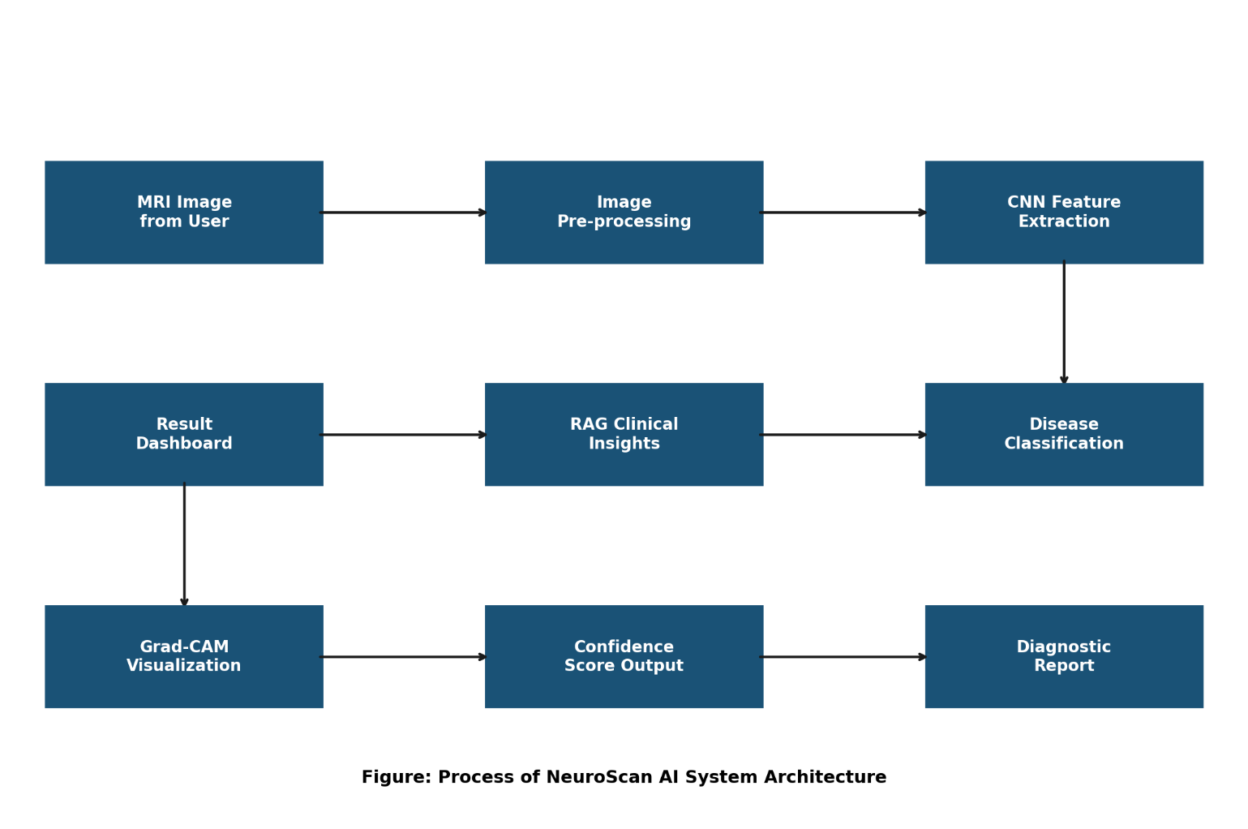

  - UML DIAGRAM’S
UML stands for Unified Modeling Language. UML is a standardized general-purpose modeling language in the field of object-oriented software engineering. The standard is managed, and was created by, the Object Management Group.

The goal is for UML to become a common language for creating models of object oriented computer software. In its current form UML is comprised of two major components: a Meta- model and a notation. In the future, some form of method or process may also be added to; or associated with, UML.
The Unified Modeling Language is a standard language for specifying, Visualization, Constructing and documenting the artifacts of software system, as well as for business modeling and other non-software systems.

The UML represents a collection of best engineering practices that have proven successful in the modeling of large and complex systems.

The UML is a very important part of developing objects oriented software and the software development process. The UML uses mostly graphical notations to express the design of software projects.
GOALS:
The Primary goals in the design of the UML are as follows:
- Provide users a ready-to-use, expressive visual modeling Language so that they can develop and exchange meaningful models.
- Provide extendibility and specialization mechanisms to extend the core concepts.
- Be independent of particular programming languages and development process.
- Provide a formal basis for understanding the modeling language.
- Encourage the growth of OO tools market.
- Support higher level development concepts such as collaborations, frameworks, patterns and components.
- Integrate best practices.

6.2.1 USE CASE DIAGRAM:

A use case diagram in the Unified Modeling Language (UML) is a type of behavioral diagram defined by and created from a Use-case analysis. Its purpose is to present a graphical overview of the functionality provided by a system in terms of actors, their goals (represented as use cases), and any dependencies between those use cases. The main purpose of a use case diagram is to show what system functions are performed for which actor. Roles of the actors in the system can be depicted.

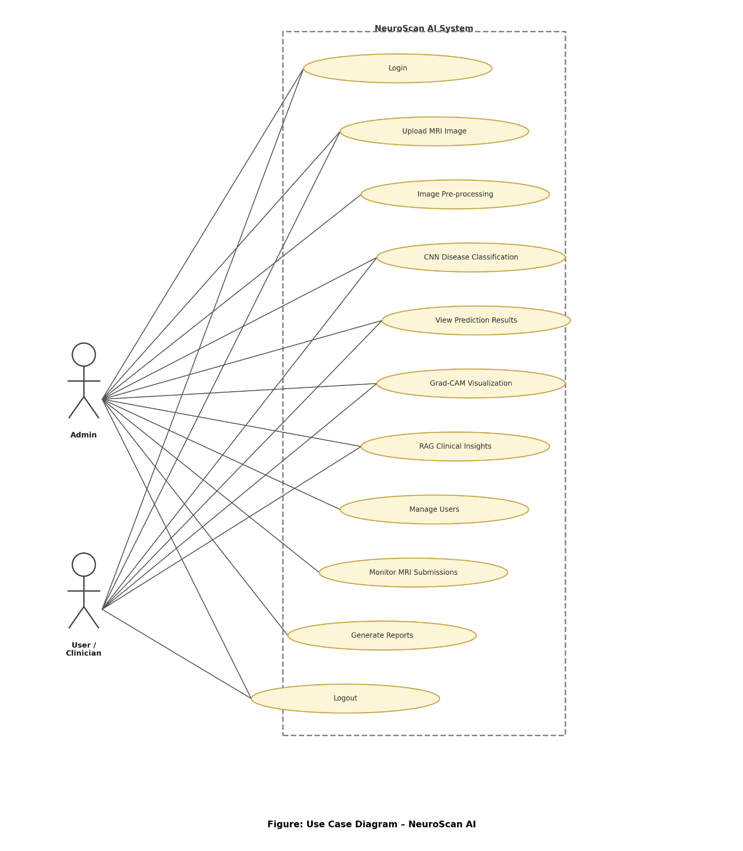

6.2.2 CLASS DIAGRAM:

In software engineering, a class diagram in the Unified Modeling Language (UML) is a type of static structure diagram that describes the structure of a system by showing the system's classes, their attributes, operations (or methods), and the relationships among the classes. It explains which class contains information.
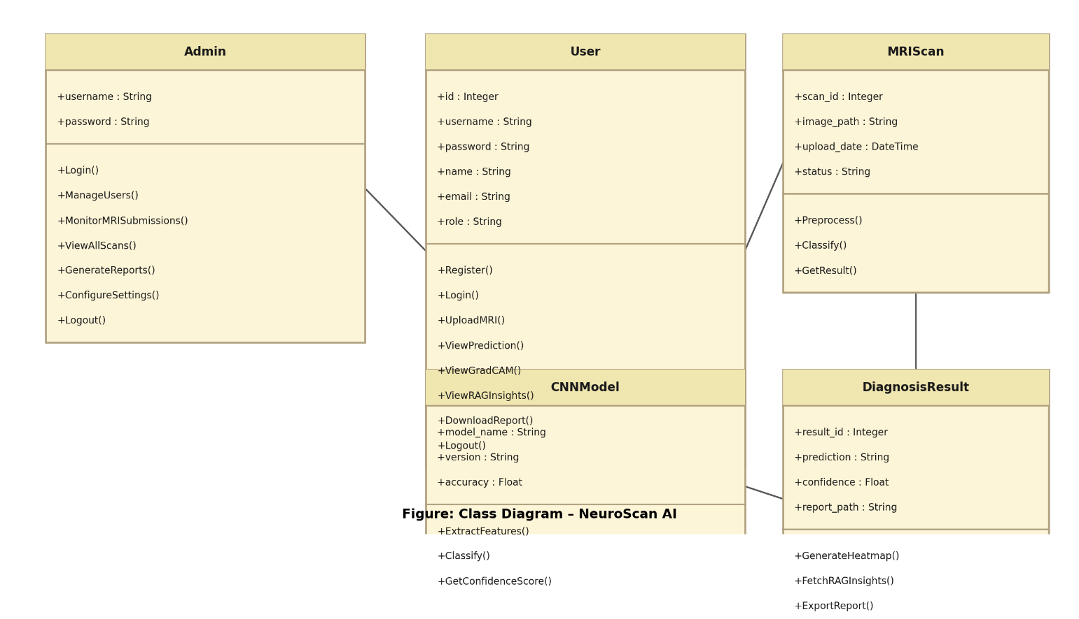

6.2.3 SEQUENCE DIAGRAM:

A sequence diagram in Unified Modeling Language (UML) is a kind of interaction diagram that shows how processes operate with one another and in what order. It is a construct of a Message Sequence Chart. Sequence diagrams are sometimes called event diagrams, event scenarios, and timing diagrams.

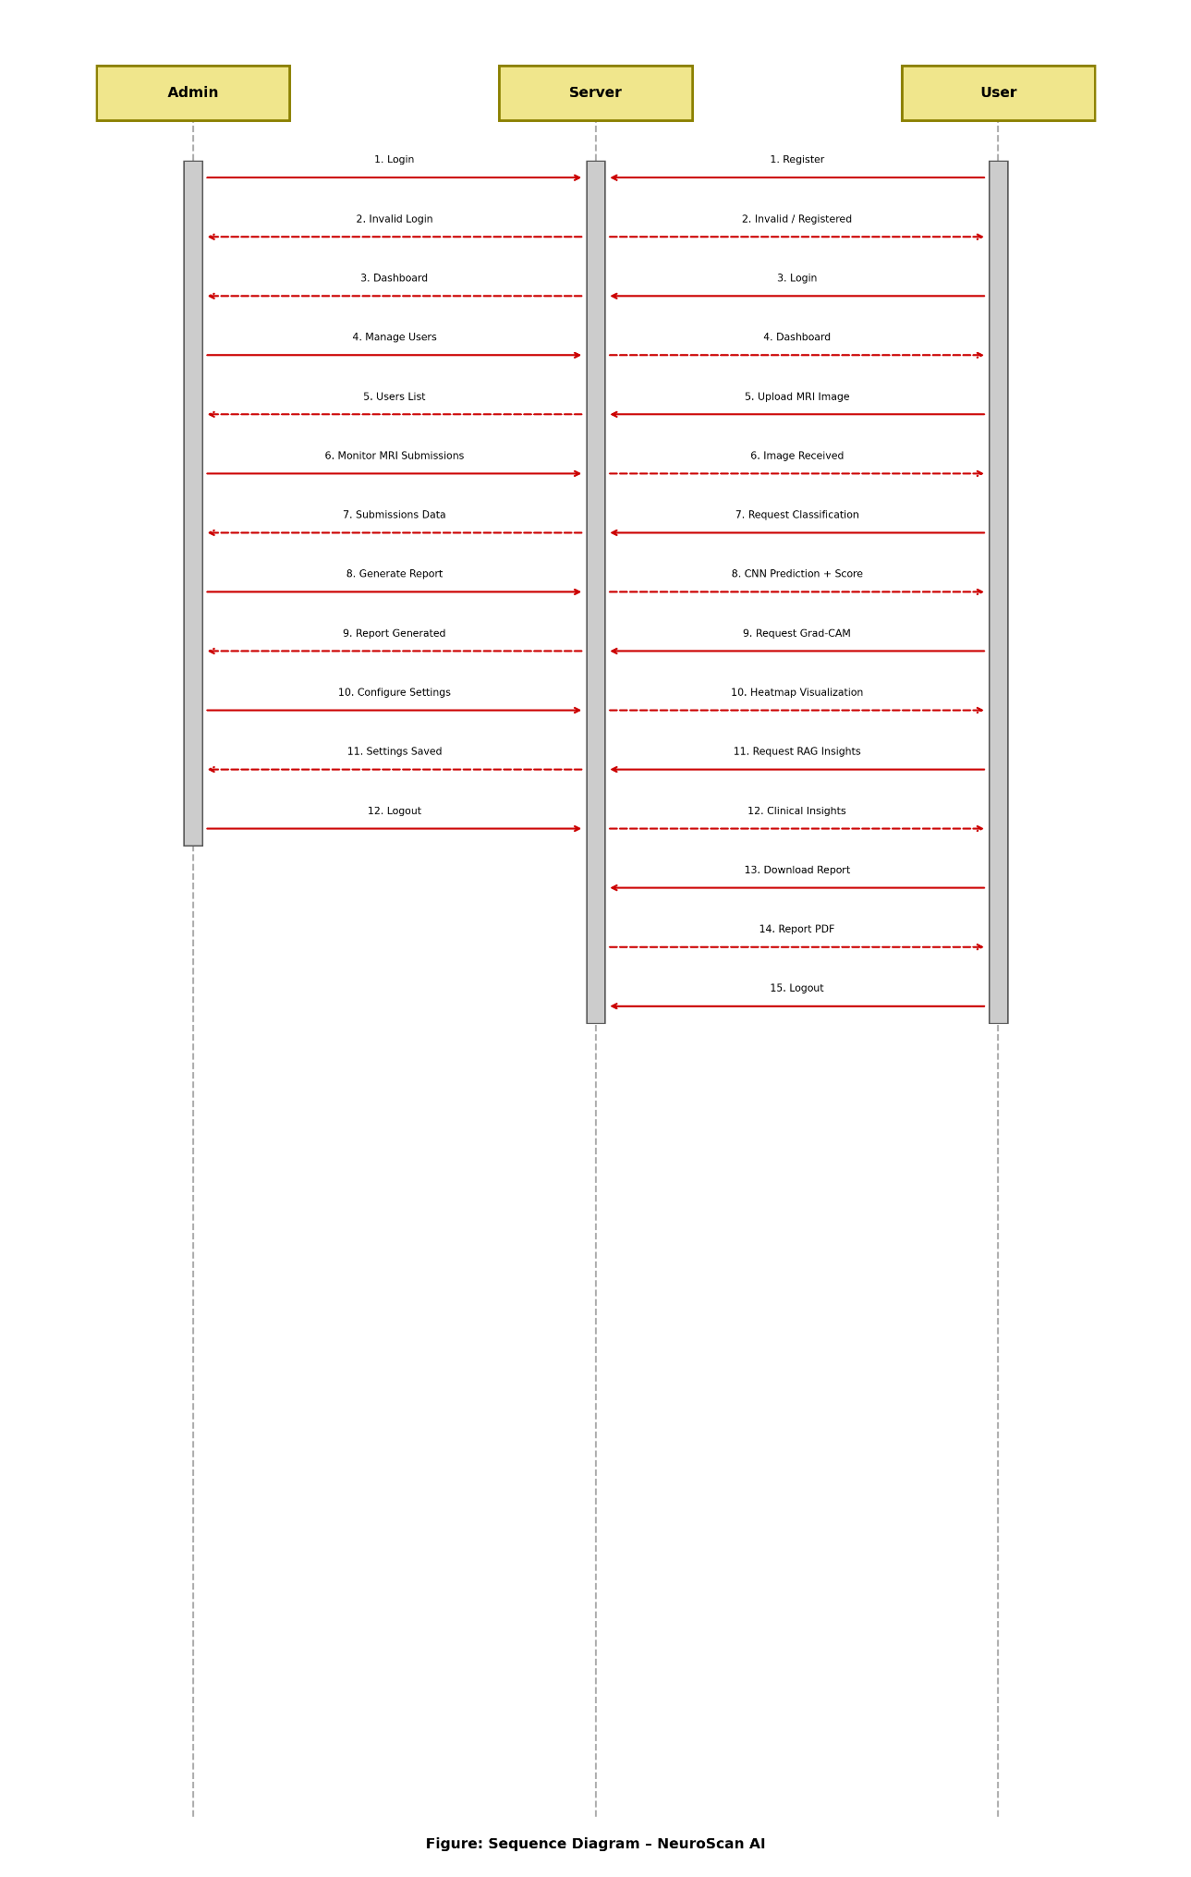

6.2.4 COLLABRATION DIAGRAM:
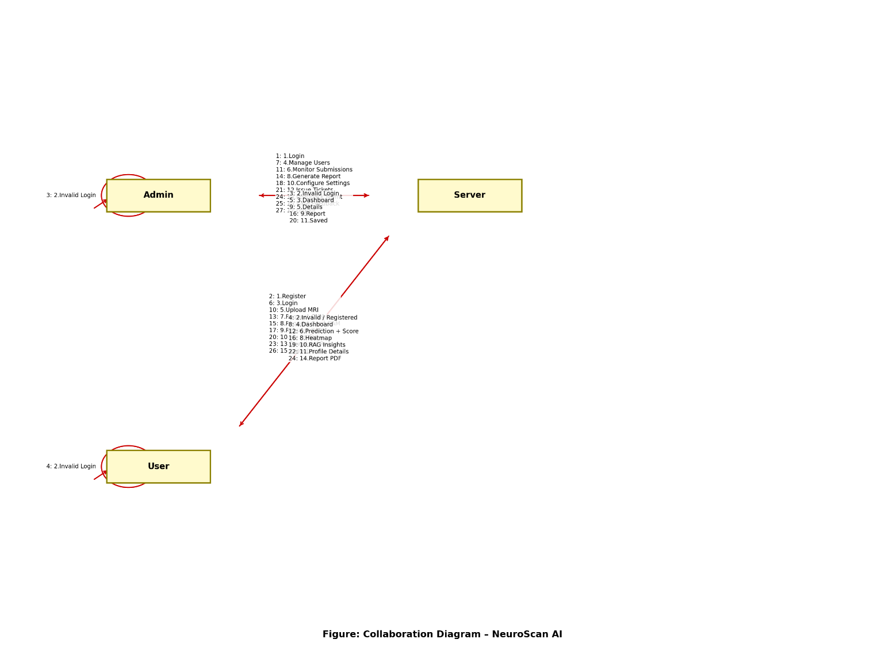

6.2.5 ACTIVITY DIAGRAM

An activity diagram, a type of UML diagram, visually represents the flow of control or activities within a system or process, utilizing standardized symbols such as rectangles for activities, diamonds for decision points, and arrows for transitions. It is extensively used in business process modeling to depict workflows and in software engineering to illustrate algorithmic logic or system behavior. Activity diagrams consist of activities representing actions or steps, transitions indicating the flow between activities, decision points for branching based on conditions, and start and end nodes marking the beginning and conclusion of the process. They offer clarity in understanding and communicating complex processes,
aiding in analysis, optimization, and documentation, thus serving as essential tools for both business and software development contexts.

ADMIN

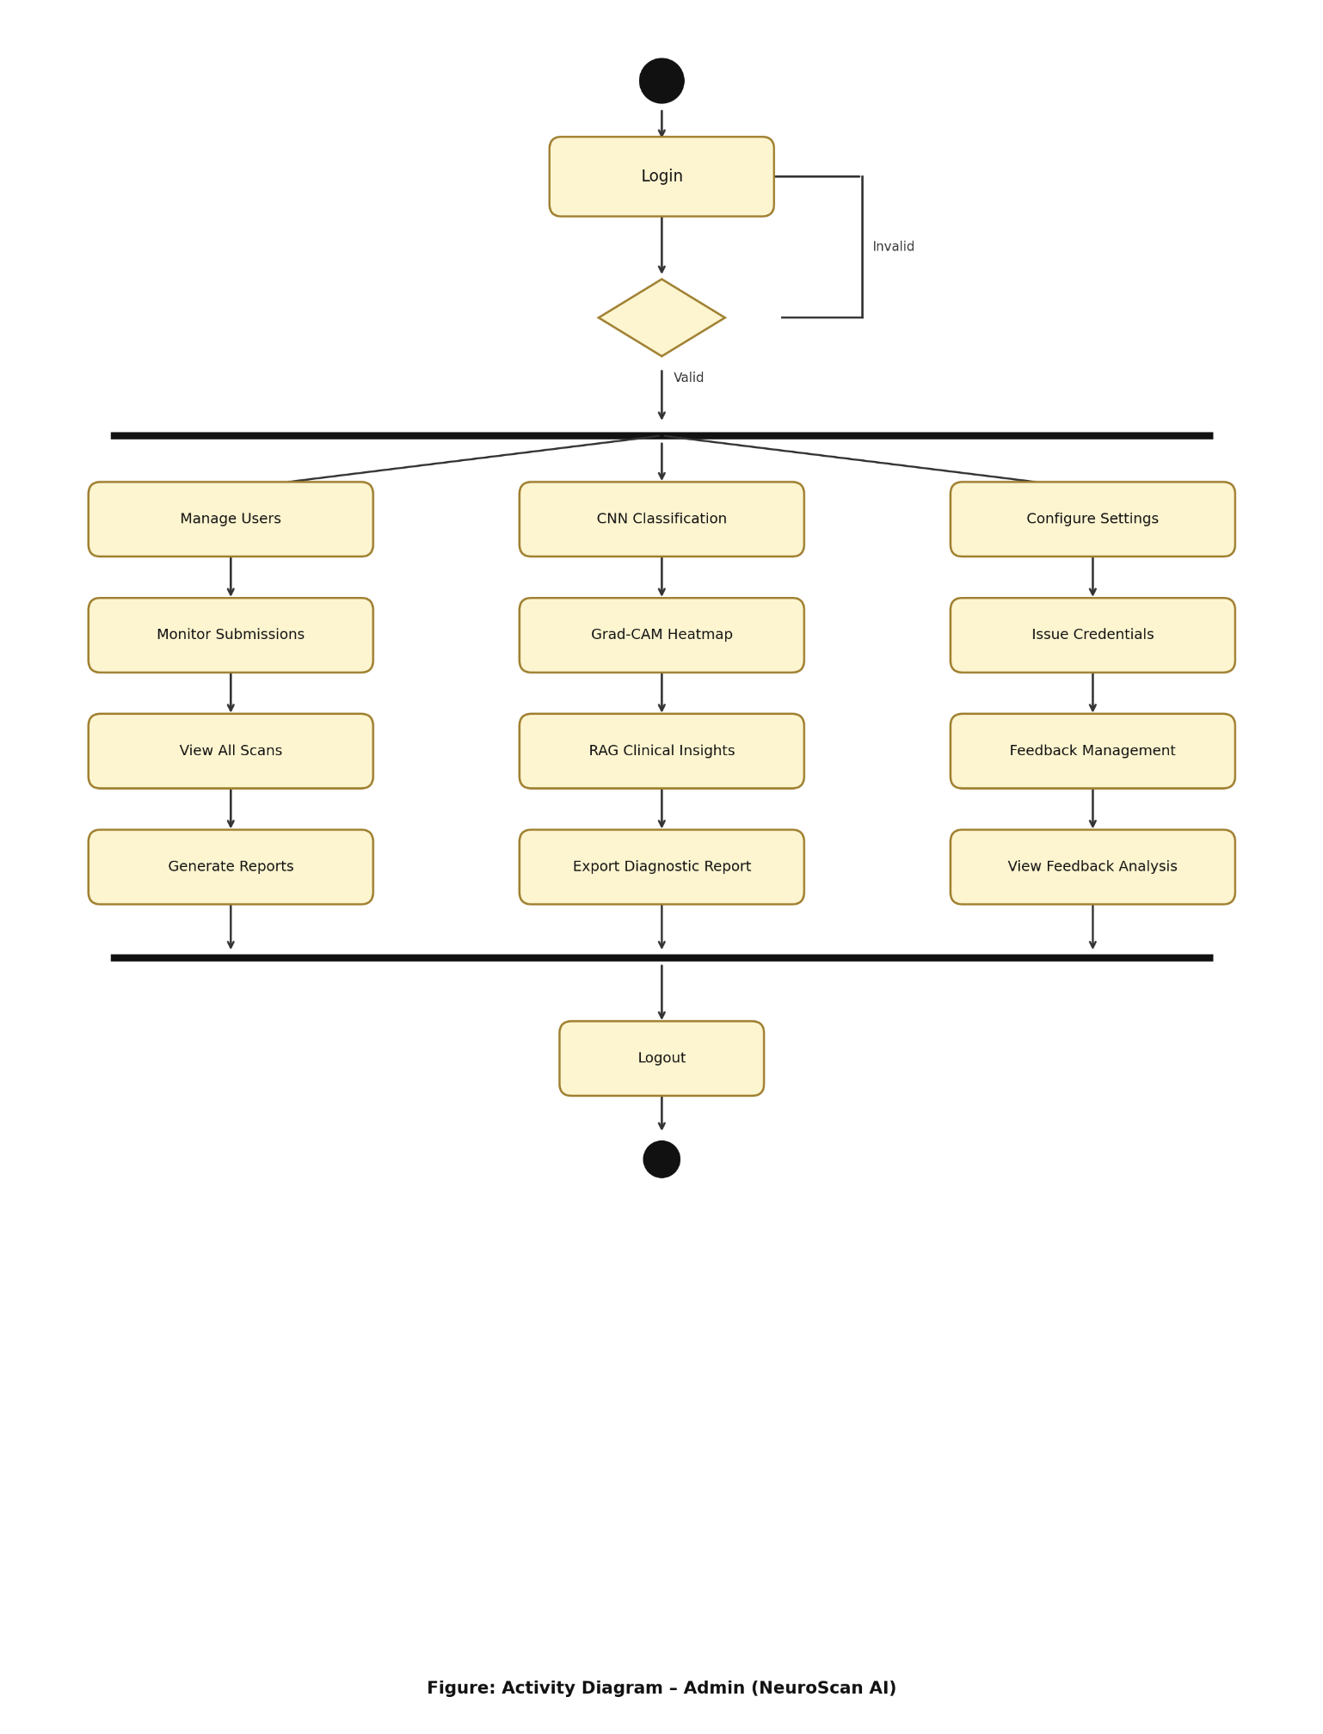

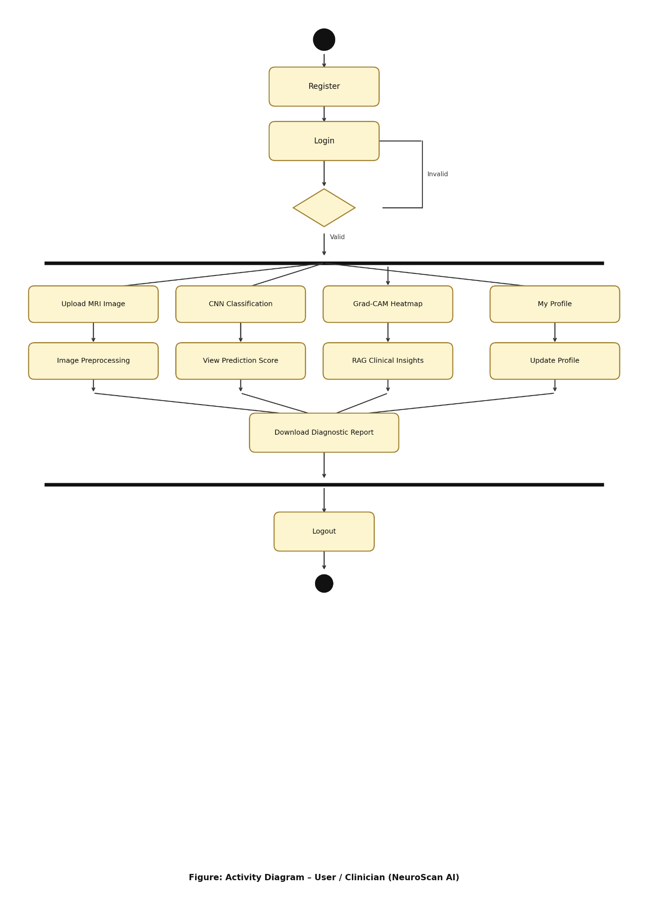

6.2.6 COMPONENT DIAGRAM:

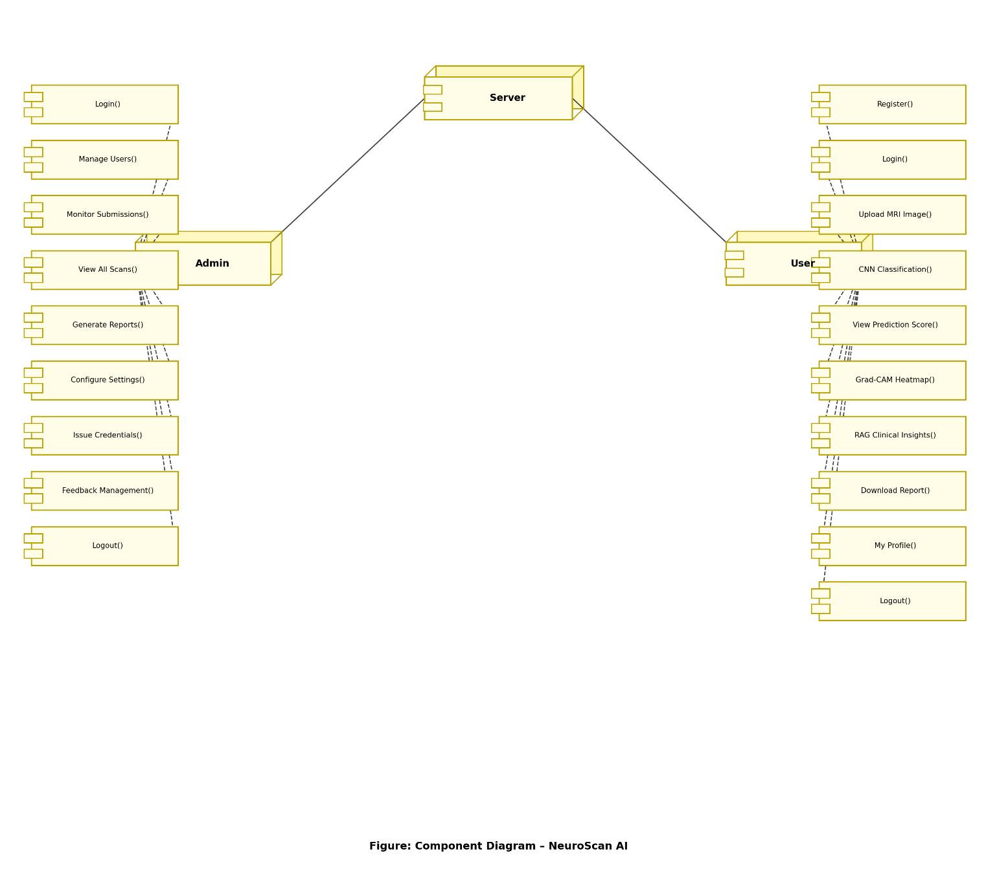
6.2.7 DEPLOYMENT DIAGRAM

A UML deployment diagram is a diagram that shows the configuration of run time processing nodes and the components that live on them. Deployment diagrams is a kind of structure diagram used in modeling the physical aspects of an object-oriented system. They are often be used to model the static deployment view of a system (topology of the hardware).
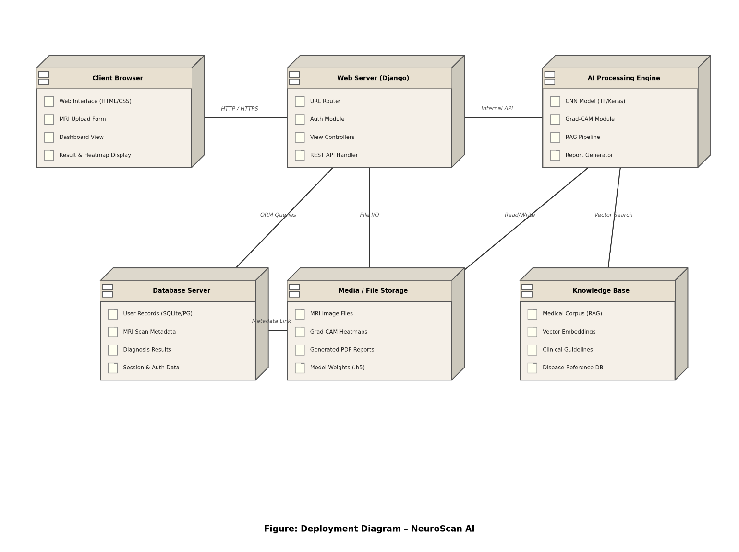

6.2.8 ER DIAGRAM: 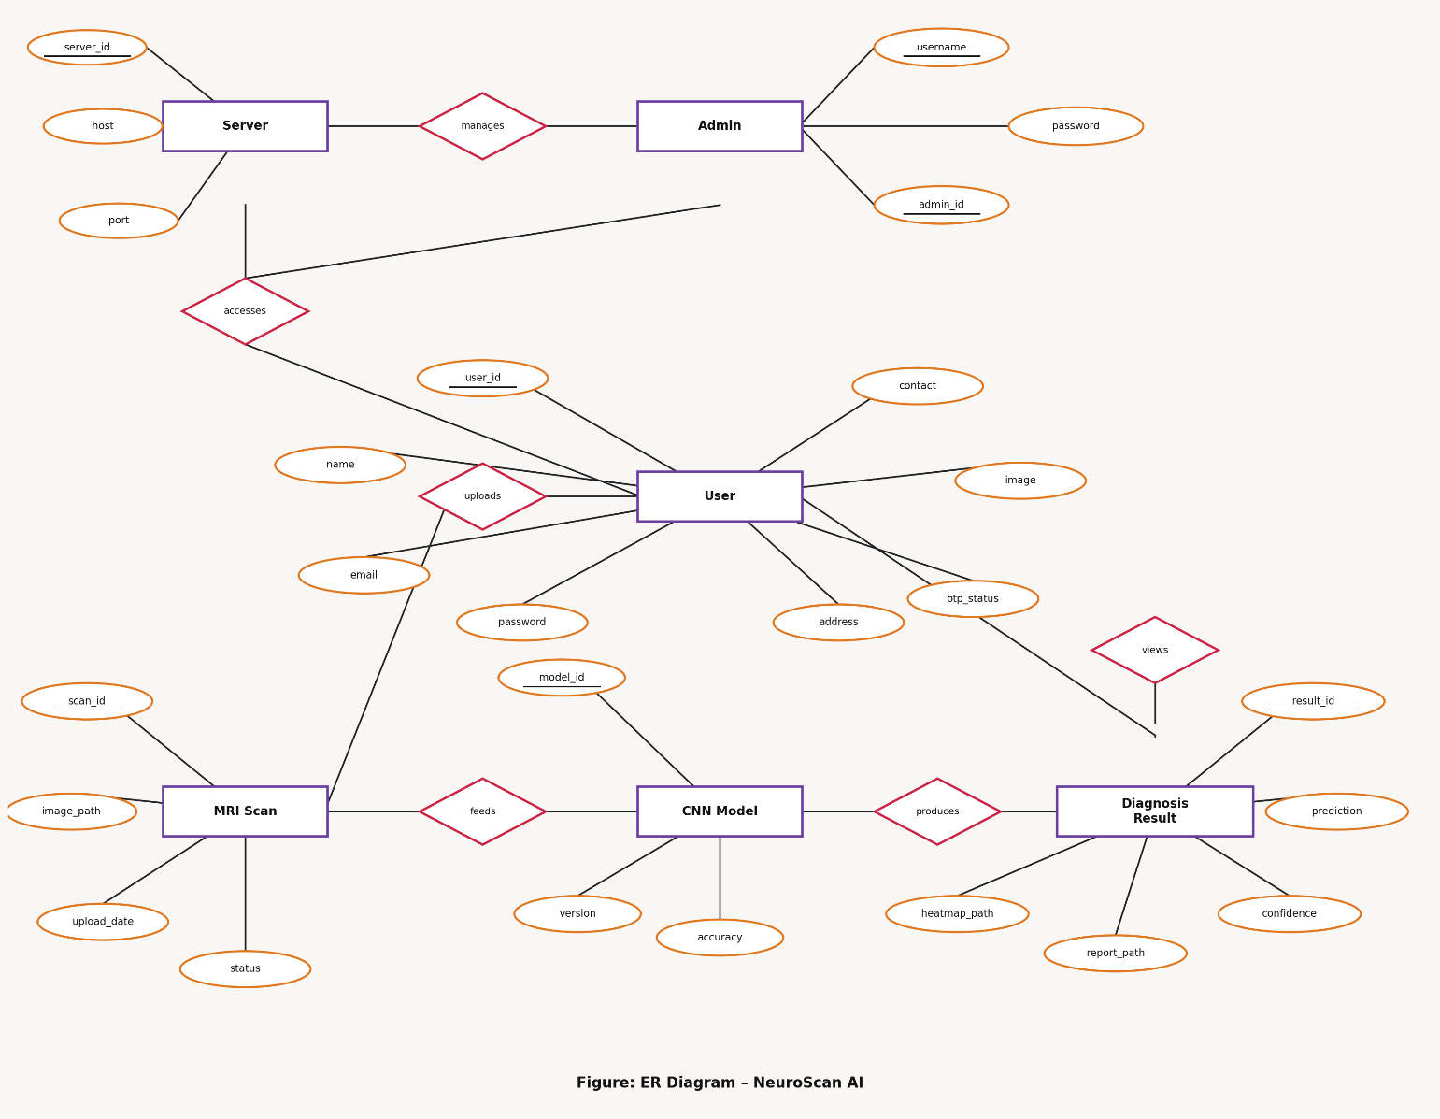

6.2.9 DATA DICTIONARIES:

auth_group
Table comments: auth_group
Column | Type | Null | Default
id | int(11) | No
name | varchar(150) | No

auth_group_permissions
Table comments: auth_group_permissions
Column | Type | Null | Default
id | bigint(20) | No
group_id | int(11) | No
permission_id | int(11) | No

auth_permission
Table comments: auth_permission
Column | Type | Null | Default
id | int(11) | No
name | varchar(255) | No
content_type_id | int(11) | No
codename | varchar(100) | No

auth_user
Table comments: auth_user
Column | Type | Null | Default
id | int(11) | No
password | varchar(128) | No
last_login | datetime(6) | Yes | NULL
is_superuser | tinyint(1) | No
username | varchar(150) | No
first_name | varchar(150) | No
last_name | varchar(150) | No
email | varchar(254) | No
is_staff | tinyint(1) | No
is_active | tinyint(1) | No
date_joined | datetime(6) | No

auth_user_groups
Table comments: auth_user_groups
Column | Type | Null | Default
id | bigint(20) | No
user_id | int(11) | No
group_id | int(11) | No

auth_user_user_permissions
Table comments: auth_user_user_permissions
Column | Type | Null | Default
id | bigint(20) | No
user_id | int(11) | No

django_admin_log
Table comments: django_admin_log
Column | Type | Null | Default
id | int(11) | No
action_time | datetime(6) | No
object_id | longtext
object_repr | varchar(200) | No
action_flag | smallint(5) | No
change_message | longtext | No
content_type_id | int(11) |  | NULL
user_id | int(11) | No

django_content_type
Table comments: django_content_type
Column | Type | Null | Default
id | int(11) | No
app_label | varchar(100) | No
model | varchar(100) | No

django_migrations
Table comments: django_migrations
Column | Type | Null | Default
id | bigint(20) | No
app | varchar(255) | No
name | varchar(255) | No
applied | datetime(6) | No

django_session
Table comments: django_session

Image_conversion
Table comments: image_conversion
Column | Type | Null | Default
Img_id | int(11) | No
image | varchar(100) | No

CHAPTER-7

INPUT AND OUTPUT DESIGN

INPUT DESIGN

The input design is the link between the information system and the user. It comprises the developing specification and procedures for data preparation and those steps are necessary to put transaction data in to a usable form for processing can be achieved by inspecting the computer to read data from a written or printed document or it can occur by having people keying the data directly into the system. The design of input focuses on controlling the amount of input required, controlling the errors, avoiding delay, avoiding extra steps and keeping the process simple. The input is designed in such a way so that it provides security and ease of use with retaining the privacy. Input Design considered the following things:
- What data should be given as input?
- How the data should be arranged or coded?
- The dialog to guide the operating personnel in providing input.
- Methods for preparing input validations and steps to follow when error occur.

OBJECTIVES

- Input Design is the process of converting a user-oriented description of the input into a computer-based system. This design is important to avoid errors in the data input process and show the correct direction to the management for getting correct information from the computerized system.
- It is achieved by creating user-friendly screens for the data entry to handle large volume of data. The goal of designing input is to make data entry easier and to be free from errors. The data entry screen is designed in such a way that all the data manipulates can be performed. It also provides record viewing facilities.

- When the data is entered it will check for its validity. Data can be entered with the help of screens. Appropriate messages are provided as when needed so that the user will not be in maize of instant. Thus the objective of input design is to create an input layout that is easy to follow.

OUTPUT DESIGN

A quality output is one, which meets the requirements of the end user and presents the information clearly. In any system results of processing are communicated to the users and to other system through outputs. In output design it is determined how the information is to be displaced for immediate need and also the hard copy output. It is the most important and direct source information to the user. Efficient and intelligent output design improves the system’s relationship to help user decision-making.
- Designing computer output should proceed in an organized, well thought out manner; the right output must be developed while ensuring that each output element is designed so that people will find the system can use easily and effectively. When analysis design computer output, they should Identify the specific output that is needed to meet the requirements.
- Select methods for presenting information.

- Create document, report, or other formats that contain information produced by the system.

The output form of an information system should accomplish one or more of the following objectives.
- Convey information about past activities, current status or projections of the
- Future.
- Signal important events, opportunities, problems, or warnings.
- Trigger an action.
- Confirm an action.

CHAPTER-8

IMPLEMENTATION

MODULES

- Admin
- User

MODULE DESCRIPTION
Vehicle Plate Identification Module:

This module employs advanced deep learning algorithms to enhance the accuracy of vehicle plate identification. It processes images captured by the PI camera at the parking entrance, ensuring reliable and swift recognition of registration plates.
Sensor Integration and Calibration Module:

Focused on improving the reliability of parking slot availability detection, this module manages the integration of various sensors, including IR sensors and potentially alternative technologies. It also implements a robust calibration and maintenance protocol to ensure the accuracy of sensor data over time.
Extended Sensor Technology Module:

Addressing the limitation of IR sensor detection range, this module explores and integrates alternative sensor technologies with extended coverage capabilities. By enhancing the sensor network, the system ensures comprehensive coverage of parking areas, minimizing the chances of overlooking available parking spaces.

Offline Functionality Module:

This module introduces offline functionality to the mobile application, allowing users to access critical parking information and make reservations even in the absence of continuous network connectivity. It ensures uninterrupted service availability, catering to user needs in various network conditions.
Security Infrastructure Module:

Emphasizing the security of user data, this module implements robust encryption and authentication measures. It ensures secure transmission of data from sensing devices to the cloud service, instilling user confidence in the system's commitment to protecting sensitive information.

CHAPTER-9 SOFTWARE ENVIRONMENT

PYTHON

What is Python

Below are some facts about Python. Python is currently the most widely used multi-purpose, high-level programming language.
Python allows programming in Object-Oriented and Procedural paradigms. Python programs generally are smaller than other programming languages like Java Programmers have to type relatively less and indentation requirement of the language, makes them readable all the time.

Python language is being used by almost all tech-giant companies like – Google, Amazon, Facebook, Instagram, Dropbox, Uber… etc. The biggest strength of Python is huge collection of standard library which can be used for the following –

  - Machine Learning
  - GUI Applications (like Kivy, Tkinter, PyQt etc. )
  - Web frameworks like Django (used by YouTube, Instagram, Dropbox)
  - Image processing (like Opencv, Pillow)
  - Web scraping (like Scrapy, BeautifulSoup, Selenium)
  - Test frameworks
  - Multimedia

Advantages of Python :-
Let’s see how Python dominates over other languages.

Extensive Libraries

Python downloads with an extensive library and it contain code for various purposes like regular expressions, documentation-generation, unit-testing, web browsers, threading, databases, CGI, email, image manipulation, and more. So, we don’t have to write the complete code for that manually.

Extensible
As we have seen earlier, Python can be extended to other languages. You can write some of your code in languages like C++ or C. This comes in handy, especially in projects.

Embeddable
Complimentary to extensibility, Python is embeddable as well. You can put your Python code in your source code of a different language, like C++. This lets us add scripting capabilities to our code in the other language.

Improved Productivity
The language’s simplicity and extensive libraries render programmers more productive than languages like Java and C++ do. Also, the fact that you need to write less and get more things done.

IOT Opportunities
Since Python forms the basis of new platforms like Raspberry Pi, it finds the future bright for the Internet Of Things. This is a way to connect the language with the real world. When working with Java, you may have to create a class to print ‘Hello World’. But in Python, just a print statement will do. It is also quite easy to learn, understand, and code. This is why when people pick up Python, they have a hard time adjusting to other more verbose languages like Java.

Readable
Because it is not such a verbose language, reading Python is much like reading English. This is the reason why it is so easy to learn, understand, and code. It also does not need

curly braces to define blocks, and indentation is mandatory. This further aids the readability of the code.

Object-Oriented
This language supports both the procedural and object-oriented programming paradigms. While functions help us with code reusability, classes and objects let us model the real world. A class allows the encapsulation of data and functions into one.

Free and Open-Source
Like we said earlier, Python is freely available. But not only can you download Python for free, but you can also download its source code, make changes to it, and even distribute it. It downloads with an extensive collection of libraries to help you with your tasks.

Portable
When you code your project in a language like C++, you may need to make some changes to it if you want to run it on another platform. But it isn’t the same with Python. Here, you need to code only once, and you can run it anywhere. This is called Write Once Run Anywhere (WORA). However, you need to be careful enough not to include any system- dependent features.

Interpreted
Lastly, we will say that it is an interpreted language. Since statements are executed one by one, debugging is easier than in compiled languages.
Any doubts till now in the advantages of Python? Mention in the comment section.

Advantages of Python Over Other Languages :
- Less Coding
Almost all of the tasks done in Python requires less coding when the same task is done in other languages. Python also has an awesome standard library support, so you don’t have to search for any third-party libraries to get your job done. This is the reason that many people suggest learning Python to beginners.

- Affordable
Python is free therefore individuals, small companies or big organizations can leverage the free available resources to build applications. Python is popular and widely used so it gives you better community support.

The 2019 Github annual survey showed us that Python has overtaken Java in the most popular programming language category.

- Python is for Everyone
Python code can run on any machine whether it is Linux, Mac or Windows. Programmers need to learn different languages for different jobs but with Python, you can professionally build web apps, perform data analysis and machine learning, automate things, do web scraping and also build games and powerful visualizations. It is an all-rounder programming language.
Disadvantages of Python
So far, we’ve seen why Python is a great choice for your project. But if you choose it, you should be aware of its consequences as well. Let’s now see the downsides of choosing Python over another language.

Speed Limitations

We have seen that Python code is executed line by line. But since Python is interpreted, it often results in slow execution. This, however, isn’t a problem unless speed is a focal point for the project. In other words, unless high speed is a requirement, the benefits offered by Python are enough to distract us from its speed limitations.

Weak in Mobile Computing and Browsers

While it serves as an excellent server-side language, Python is much rarely seen on the client-side. Besides that, it is rarely ever used to implement smartphone-based applications. One such application is called Carbonnelle.
The reason it is not so famous despite the existence of Brython is that it isn’t that secure.

Design Restrictions

As you know, Python is dynamically-typed. This means that you don’t need to declare the type of variable while writing the code. It uses duck-typing. But wait, what’s that? Well, it just means that if it looks like a duck, it must be a duck. While this is easy on the programmers during coding, it can raise run-time errors.

Underdeveloped Database Access Layers

Compared to more widely used technologies like JDBC (Java DataBase Connectivity) and ODBC (Open DataBase Connectivity), Python’s database access layers are a bit underdeveloped. Consequently, it is less often applied in huge enterprises.

Simple

No, we’re not kidding. Python’s simplicity can indeed be a problem. Take my example. I don’t do Java, I’m more of a Python person. To me, its syntax is so simple that the verbosity of Java code seems unnecessary.
This was all about the Advantages and Disadvantages of Python Programming Language.

History of Python : -
What do the alphabet and the programming language Python have in common? Right, both start with ABC. If we are talking about ABC in the Python context, it's clear that the programming language ABC is meant. ABC is a general-purpose programming language and programming environment, which had been developed in the Netherlands, Amsterdam, at the CWI (Centrum Wiskunde &Informatica). The greatest achievement of ABC was to influence the design of Python.Python was conceptualized in the late 1980s. Guido van Rossum worked that time in a project at the CWI, called Amoeba, a distributed operating system. In an interview with Bill Venners¹, Guido van Rossum said: "In the early 1980s, I worked as an implementer on a team building a language called ABC at Centrum voor Wiskunde en Informatica (CWI). I don't know how well people know ABC's influence on Python. I try to mention ABC's influence because I'm indebted to everything I learned during that project and to the people who worked on it."Later on in the same Interview, Guido van

Rossum continued: "I remembered all my experience and some of my frustration with ABC. I decided to try to design a simple scripting language that possessed some of ABC's better properties, but without its problems. So I started typing. I created a simple virtual machine, a simple parser, and a simple runtime. I made my own version of the various ABC parts that I liked. I created a basic syntax, used indentation for statement grouping instead of curly braces or begin-end blocks, and developed a small number of powerful data types: a hash table (or dictionary, as we call it), a list, strings, and numbers."

What is Machine Learning
Before we take a look at the details of various machine learning methods, let's start by looking at what machine learning is, and what it isn't. Machine learning is often categorized as a subfield of artificial intelligence, but I find that categorization can often be misleading at first brush. The study of machine learning certainly arose from research in this context, but in the data science application of machine learning methods, it's more helpful to think of machine learning as a means of building models of data.

Fundamentally, machine learning involves building mathematical models to help understand data. "Learning" enters the fray when we give these models tunable parameters that can be adapted to observed data; in this way the program can be considered to be "learning" from the data. Once these models have been fit to previously seen data, they can be used to predict and understand aspects of newly observed data. I'll leave to the reader the more philosophical digression regarding the extent to which this type of mathematical, model-based "learning" is similar to the "learning" exhibited by the human brain.Understanding the problem setting in machine learning is essential to using these tools effectively, and so we will start with some broad categorizations of the types of approaches we'll discuss here.

Categories Of Machine Leaning :-

At the most fundamental level, machine learning can be categorized into two main types: supervised learning and unsupervised learning.

Supervised learning involves somehow modeling the relationship between measured features of data and some label associated with the data; once this model is determined, it

can be used to apply labels to new, unknown data. This is further subdivided into classification tasks and regression tasks: in classification, the labels are discrete categories, while in regression, the labels are continuous quantities. We will see examples of both types of supervised learning in the following section.

Unsupervised learning involves modeling the features of a dataset without reference to any label, and is often described as "letting the dataset speak for itself." These models include tasks such as clustering and dimensionality reduction. Clustering algorithms identify distinct groups of data, while dimensionality reduction algorithms search for more succinct representations of the data. We will see examples of both types of unsupervised learning in the following section

Need for Machine Learning

Human beings, at this moment, are the most intelligent and advanced species on earth because they can think, evaluate and solve complex problems. On the other side, AI is still in its initial stage and haven’t surpassed human intelligence in many aspects. Then the question is that what is the need to make machine learn? The most suitable reason for doing this is, “to make decisions, based on data, with efficiency and scale”.
Lately, organizations are investing heavily in newer technologies like Artificial Intelligence, Machine Learning and Deep Learning to get the key information from data to perform several real-world tasks and solve problems. We can call it data-driven decisions taken by machines, particularly to automate the process. These data-driven decisions can be used, instead of using programing logic, in the problems that cannot be programmed inherently. The fact is that we can’t do without human intelligence, but other aspect is that we all need to solve real-world problems with efficiency at a huge scale. That is why the need for machine learning arises.

Challenges in Machines Learning :-
While Machine Learning is rapidly evolving, making significant strides with cybersecurity and autonomous cars, this segment of AI as whole still has a long way to go. The reason

behind is that ML has not been able to overcome number of challenges. The challenges that ML is facing currently are −
Quality of data − Having good-quality data for ML algorithms is one of the biggest challenges. Use of low-quality data leads to the problems related to data preprocessing and feature extraction.
Time-Consuming task − Another challenge faced by ML models is the consumption of time especially for data acquisition, feature extraction and retrieval.
Lack of specialist persons − As ML technology is still in its infancy stage, availability of expert resources is a tough job.
No clear objective for formulating business problems − Having no clear objective and well-defined goal for business problems is another key challenge for ML because this technology is not that mature yet.
Issue of overfitting & underfitting − If the model is overfitting or underfitting, it cannot be represented well for the problem.
Curse of dimensionality − Another challenge ML model faces is too many features of data points. This can be a real hindrance.
Difficulty in deployment − Complexity of the ML model makes it quite difficult to be deployed in real life.

Applications of Machines Learning :-
Machine Learning is the most rapidly growing technology and according to researchers we are in the golden year of AI and ML. It is used to solve many real-world complex problems which cannot be solved with traditional approach. Following are some real-world applications of ML −

- Emotion analysis
- Sentiment analysis
- Error detection and prevention
- Weather forecasting and prediction

- Stock market analysis and forecasting
- Speech synthesis
- Speech recognition
- Customer segmentation
- Object recognition
- Fraud detection
- Fraud prevention
- Recommendation of products to customer in online shopping

How to Start Learning Machine Learning?
Arthur Samuel coined the term “Machine Learning” in 1959 and defined it as a “Field of study that gives computers the capability to learn without being explicitly programmed”.
And that was the beginning of Machine Learning! In modern times, Machine Learning is one of the most popular (if not the most!) career choices. According to Indeed, Machine Learning Engineer Is The Best Job of 2019 with a 344% growth and an average base salary of $146,085 per year.
But there is still a lot of doubt about what exactly is Machine Learning and how to start learning it? So this article deals with the Basics of Machine Learning and also the path you can follow to eventually become a full-fledged Machine Learning Engineer. Now let’s get started!!!

How to start learning ML?

This is a rough roadmap you can follow on your way to becoming an insanely talented Machine Learning Engineer. Of course, you can always modify the steps according to your needs to reach your desired end-goal!

Step 1 – Understand the Prerequisites

In case you are a genius, you could start ML directly but normally, there are some prerequisites that you need to know which include Linear Algebra, Multivariate Calculus, Statistics, and Python. And if you don’t know these, never fear! You don’t need a Ph.D. degree in these topics to get started but you do need a basic understanding.

Learn Linear Algebra and Multivariate Calculus

Both Linear Algebra and Multivariate Calculus are important in Machine Learning. However, the extent to which you need them depends on your role as a data scientist. If you are more focused on application heavy machine learning, then you will not be that heavily focused on maths as there are many common libraries available. But if you want to focus on R&D in Machine Learning, then mastery of Linear Algebra and Multivariate Calculus is very important as you will have to implement many ML algorithms from scratch.

Learn Statistics

Data plays a huge role in Machine Learning. In fact, around 80% of your time as an ML expert will be spent collecting and cleaning data. And statistics is a field that handles the collection, analysis, and presentation of data. So it is no surprise that you need to learn it!!! Some of the key concepts in statistics that are important are Statistical Significance, Probability Distributions, Hypothesis Testing, Regression, etc. Also, Bayesian Thinking is also a very important part of ML which deals with various concepts like Conditional Probability, Priors, and Posteriors, Maximum Likelihood, etc.

Learn Python

Some people prefer to skip Linear Algebra, Multivariate Calculus and Statistics and learn them as they go along with trial and error. But the one thing that you absolutely cannot skip is Python! While there are other languages you can use for Machine Learning like R, Scala, etc. Python is currently the most popular language for ML. In fact, there are many Python

libraries that are specifically useful for Artificial Intelligence and Machine Learning such as Keras, TensorFlow, Scikit-learn, etc.
So if you want to learn ML, it’s best if you learn Python! You can do that using various online resources and courses such as Fork Python available Free on GeeksforGeeks.

Step 2 – Learn Various ML Concepts

Now that you are done with the prerequisites, you can move on to actually learning ML (Which is the fun part!!!) It’s best to start with the basics and then move on to the more complicated stuff. Some of the basic concepts in ML are:

Terminologies of Machine Learning

- Model – A model is a specific representation learned from data by applying some machine learning algorithm. A model is also called a hypothesis.
- Feature – A feature is an individual measurable property of the data. A set of numeric features can be conveniently described by a feature vector. Feature vectors are fed as input to the model. For example, in order to predict a fruit, there may be features like color, smell, taste, etc.
- Target (Label) – A target variable or label is the value to be predicted by our model. For the fruit example discussed in the feature section, the label with each set of input would be the name of the fruit like apple, orange, banana, etc.
- Training – The idea is to give a set of inputs(features) and it’s expected outputs(labels), so after training, we will have a model (hypothesis) that will then map new data to one of the categories trained on.
- Prediction – Once our model is ready, it can be fed a set of inputs to which it will provide a predicted output(label).

Types of Machine Learning

- Supervised Learning – This involves learning from a training dataset with labeled data using classification and regression models. This learning process continues until the required level of performance is achieved.
- Unsupervised Learning – This involves using unlabelled data and then finding the underlying structure in the data in order to learn more and more about the data itself using factor and cluster analysis models.
- Semi-supervised Learning – This involves using unlabelled data like Unsupervised Learning with a small amount of labeled data. Using labeled data vastly increases the learning accuracy and is also more cost-effective than Supervised Learning.
- Reinforcement Learning – This involves learning optimal actions through trial and error. So the next action is decided by learning behaviors that are based on the current state and that will maximize the reward in the future.
Advantages of Machine learning :-

Easily identifies trends and patterns -

Machine Learning can review large volumes of data and discover specific trends and patterns that would not be apparent to humans. For instance, for an e-commerce website like Amazon, it serves to understand the browsing behaviors and purchase histories of its users to help cater to the right products, deals, and reminders relevant to them. It uses the results to reveal relevant advertisements to them.

No human intervention needed (automation)

With ML, you don’t need to babysit your project every step of the way. Since it means giving machines the ability to learn, it lets them make predictions and also improve the algorithms on their own. A common example of this is anti-virus softwares; they learn to filter new threats as they are recognized. ML is also good at recognizing spam.

Continuous Improvement

As ML algorithms gain experience, they keep improving in accuracy and efficiency. This lets them make better decisions. Say you need to make a weather forecast model. As the amount of data you have keeps growing, your algorithms learn to make more accurate predictions faster.

Handling multi-dimensional and multi-variety data

Machine Learning algorithms are good at handling data that are multi-dimensional and multi- variety, and they can do this in dynamic or uncertain environments.

Wide Applications

You could be an e-tailer or a healthcare provider and make ML work for you. Where it does apply, it holds the capability to help deliver a much more personal experience to customers while also targeting the right customers.

Disadvantages of Machine Learning :-

Data Acquisition

Machine Learning requires massive data sets to train on, and these should be inclusive/unbiased, and of good quality. There can also be times where they must wait for new data to be generated.

Time and Resources

ML needs enough time to let the algorithms learn and develop enough to fulfill their purpose with a considerable amount of accuracy and relevancy. It also needs massive resources to function. This can mean additional requirements of computer power for you.

Interpretation of Results

Another major challenge is the ability to accurately interpret results generated by the algorithms. You must also carefully choose the algorithms for your purpose.

High error-susceptibility

Machine Learning is autonomous but highly susceptible to errors. Suppose you train an algorithm with data sets small enough to not be inclusive. You end up with biased predictions coming from a biased training set. This leads to irrelevant advertisements being displayed to customers. In the case of ML, such blunders can set off a chain of errors that can go undetected for long periods of time. And when they do get noticed, it takes quite some time to recognize the source of the issue, and even longer to correct it.

Python Development Steps : -

Guido Van Rossum published the first version of Python code (version 0.9.0) at alt.sources in February 1991. This release included already exception handling, functions, and the core data types of list, dict, str and others. It was also object oriented and had a module system. Python version 1.0 was released in January 1994. The major new features included in this release were the functional programming tools lambda, map, filter and reduce, which Guido Van Rossum never liked.Six and a half years later in October 2000, Python 2.0 was introduced. This release included list comprehensions, a full garbage collector and it was supporting unicode.Python flourished for another 8 years in the versions 2.x before the next major release as Python 3.0 (also known as "Python 3000" and "Py3K") was released. Python 3 is not backwards compatible with Python 2.x. The emphasis in Python 3 had been on the removal of duplicate programming constructs and modules, thus fulfilling or coming close to fulfilling the 13th law of the Zen of Python: "There should be one -- and preferably only one
-- obvious way to do it."Some changes in Python 7.3:

- Print is now a function
- Views and iterators instead of lists
- The rules for ordering comparisons have been simplified. E.g. a heterogeneous list cannot be sorted, because all the elements of a list must be comparable to each other.
- There is only one integer type left, i.e. int. long is int as well.
- The division of two integers returns a float instead of an integer. "//" can be used to have the "old" behaviour.

- Text Vs. Data Instead Of Unicode Vs. 8-bit

Purpose :-

We demonstrated that our approach enables successful segmentation of intra-retinal layers— even with low-quality images containing speckle noise, low contrast, and different intensity ranges throughout—with the assistance of the ANIS feature.

Python
Python is an interpreted high-level programming language for general-purpose programming. Created by Guido van Rossum and first released in 1991, Python has a design philosophy that emphasizes code readability, notably using significant whitespace.
Python features a dynamic type system and automatic memory management. It supports multiple programming paradigms, including object-oriented, imperative, functional and procedural, and has a large and comprehensive standard library.
- Python is Interpreted − Python is processed at runtime by the interpreter. You do not need to compile your program before executing it. This is similar to PERL and PHP.
- Python is Interactive − you can actually sit at a Python prompt and interact with the interpreter directly to write your programs.
Python also acknowledges that speed of development is important. Readable and terse code is part of this, and so is access to powerful constructs that avoid tedious repetition of code. Maintainability also ties into this may be an all but useless metric, but it does say something about how much code you have to scan, read and/or understand to troubleshoot problems or tweak behaviors. This speed of development, the ease with which a programmer of other languages can pick up basic Python skills and the huge standard library is key to another area where Python excels. All its tools have been quick to implement, saved a lot of time, and several of them have later been patched and updated by people with no Python background - without breaking.

Modules Used in Project :-

Tensorflow
TensorFlow is a free and open-source software library for dataflow and differentiable programming across a range of tasks. It is a symbolic math library, and is also used for machine learning applications such as neural networks. It is used for both research and production at Google.
TensorFlow was developed by the Google Brain team for internal Google use. It was released under the Apache 2.0 open-source license on November 9, 2015.

Numpy

Numpy is a general-purpose array-processing package. It provides a high-performance multidimensional array object, and tools for working with these arrays.
It is the fundamental package for scientific computing with Python. It contains various features including these important ones:
- A powerful N-dimensional array object
- Sophisticated (broadcasting) functions
- Tools for integrating C/C++ and Fortran code
- Useful linear algebra, Fourier transform, and random number capabilities
Besides its obvious scientific uses, Numpy can also be used as an efficient multi-dimensional container of generic data. Arbitrary data-types can be defined using Numpy which allows Numpy to seamlessly and speedily integrate with a wide variety of databases.

Pandas
Pandas is an open-source Python Library providing high-performance data manipulation and analysis tool using its powerful data structures. Python was majorly used for data munging and preparation. It had very little contribution towards data analysis. Pandas solved this problem. Using Pandas, we can accomplish five typical steps in the processing and analysis of data, regardless of the origin of data load, prepare, manipulate, model, and analyze. Python with Pandas is used in a wide range of fields including academic and commercial domains including finance, economics, Statistics, analytics, etc.

Matplotlib

Matplotlib is a Python 2D plotting library which produces publication quality figures in a variety of hardcopy formats and interactive environments across platforms. Matplotlib can be used in Python scripts, the Python and IPython shells, the Jupyter Notebook, web application servers, and four graphical user interface toolkits. Matplotlib tries to make easy things easy and hard things possible. You can generate plots, histograms, power spectra, bar charts, error charts, scatter plots, etc., with just a few lines of code. For examples, see the sample plots and thumbnail gallery.
For simple plotting the pyplot module provides a MATLAB-like interface, particularly when combined with IPython. For the power user, you have full control of line styles, font properties, axes properties, etc, via an object oriented interface or via a set of functions familiar to MATLAB users.

Scikit – learn

Scikit-learn provides a range of supervised and unsupervised learning algorithms via a consistent interface in Python. It is licensed under a permissive simplified BSD license and is distributed under many Linux distributions, encouraging academic and commercial use. Python
Python is an interpreted high-level programming language for general-purpose programming. Created by Guido van Rossum and first released in 1991, Python has a design philosophy that emphasizes code readability, notably using significant whitespace.
Python features a dynamic type system and automatic memory management. It supports multiple programming paradigms, including object-oriented, imperative, functional and procedural, and has a large and comprehensive standard library.
- Python is Interpreted − Python is processed at runtime by the interpreter. You do not need to compile your program before executing it. This is similar to PERL and PHP.
- Python is Interactive − you can actually sit at a Python prompt and interact with the interpreter directly to write your programs.
Python also acknowledges that speed of development is important. Readable and terse code is part of this, and so is access to powerful constructs that avoid tedious repetition of code. Maintainability also ties into this may be an all but useless metric, but it does say something

about how much code you have to scan, read and/or understand to troubleshoot problems or tweak behaviors. This speed of development, the ease with which a programmer of other languages can pick up basic Python skills and the huge standard library is key to another area where Python excels. All its tools have been quick to implement, saved a lot of time, and several of them have later been patched and updated by people with no Python background - without breaking.

Install Python Step-by-Step in Windows and Mac :
Python a versatile programming language doesn’t come pre-installed on your computer devices. Python was first released in the year 1991 and until today it is a very popular high- level programming language. Its style philosophy emphasizes code readability with its notable use of great whitespace.
The object-oriented approach and language construct provided by Python enables programmers to write both clear and logical code for projects. This software does not come pre-packaged with Windows.
How to Install Python on Windows and Mac :
There have been several updates in the Python version over the years. The question is how to install Python? It might be confusing for the beginner who is willing to start learning Python but this tutorial will solve your query. The latest or the newest version of Python is version 3.7.4 or in other words, it is Python 3.
Note: The python version 3.7.4 cannot be used on Windows XP or earlier devices.
Before you start with the installation process of Python. First, you need to know about your System Requirements. Based on your system type i.e. operating system and based processor, you must download the python version. My system type is a Windows 64-bit operating system. So the steps below are to install python version 3.7.4 on Windows 7 device or to install Python 3. Download the Python Cheatsheet here.The steps on how to install Python on Windows 10, 8 and 7 are divided into 4 parts to help understand better.

Download the Correct version into the system
Step 1: Go to the official site to download and install python using Google Chrome or any other web browser. OR Click on the following link: https://www.python.org

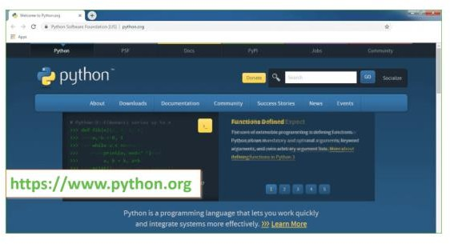

Now, check for the latest and the correct version for your operating system.
Step 2: Click on the Download Tab.
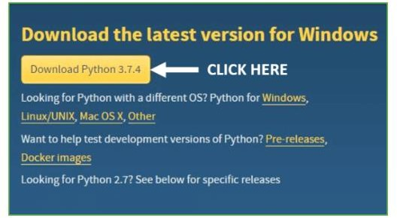

Step 3: You can either select the Download Python for windows 3.7.4 button in Yellow Color or you can scroll further down and click on download with respective to their version. Here, we are downloading the most recent python version for windows 3.7.4

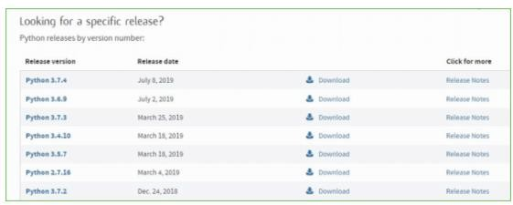

Step 4: Scroll down the page until you find the Files option.

Step 5: Here you see a different version of python along with the operating system.

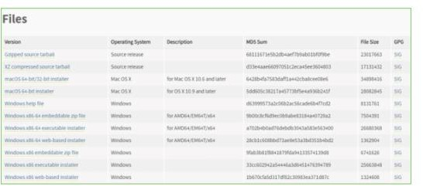

  - To download Windows 32-bit python, you can select any one from the three options: Windows x86 embeddable zip file, Windows x86 executable installer or Windows x86 web- based installer.
  - To download Windows 64-bit python, you can select any one from the three options: Windows x86-64 embeddable zip file, Windows x86-64 executable installer or Windows x86-64 web- based installer.

Here we will install Windows x86-64 web-based installer. Here your first part regarding which version of python is to be downloaded is completed. Now we move ahead with the second part in installing python i.e. Installation
Note: To know the changes or updates that are made in the version you can click on the Release Note Option.
Installation of Python
Step 1: Go to Download and Open the downloaded python version to carry out the installation process.
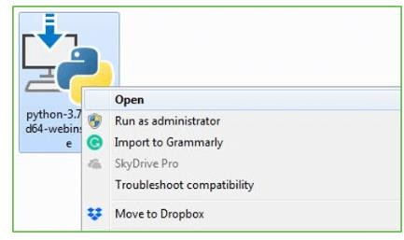

Step 2: Before you click on Install Now, Make sure to put a tick on Add Python 3.7 to PATH.

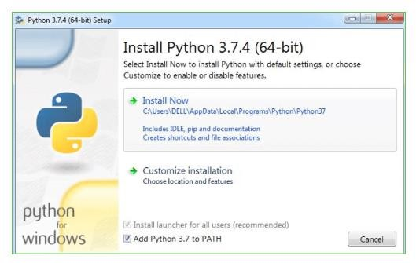

Step 3: Click on Install NOW After the installation is successful. Click on Close.

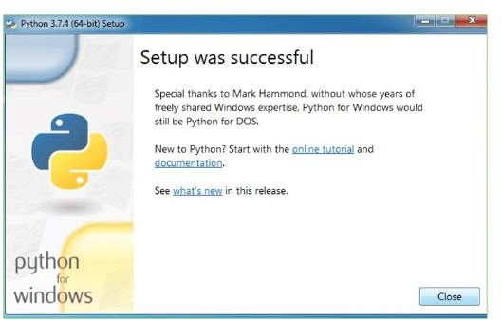

With these above three steps on python installation, you have successfully and correctly installed Python. Now is the time to verify the installation.

Note: The installation process might take a couple of minutes.

Verify the Python Installation
Step 1: Click on Start
Step 2: In the Windows Run Command, type “cmd”.

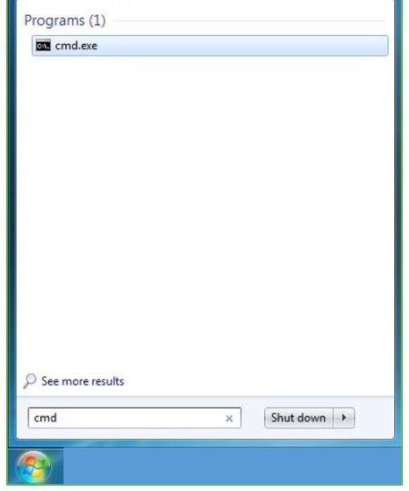
Step 3: Open the Command prompt option.
Step 4: Let us test whether the python is correctly installed. Type python –V and press Enter.

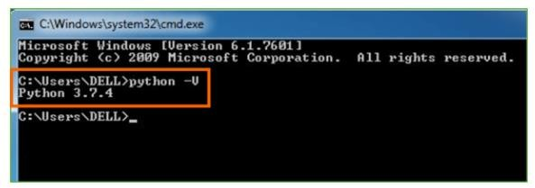

Step 5: You will get the answer as 3.7.4

Note: If you have any of the earlier versions of Python already installed. You must first uninstall the earlier version and then install the new one.

Check how the Python IDLE works
Step 1: Click on Start
Step 2: In the Windows Run command, type “python idle”.
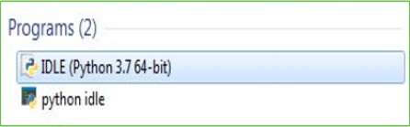
Step 3: Click on IDLE (Python 3.7 64-bit) and launch the program
Step 4: To go ahead with working in IDLE you must first save the file. Click on File > Click on Save
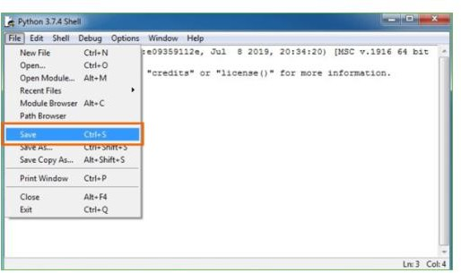
Step 5: Name the file and save as type should be Python files. Click on SAVE. Here I have named the files as Hey World.
Step 6: Now for e.g. enter print

9.2 SOURCE CODE

Manage.Py

#!/usr/bin/env python

"""Django's command-line utility for administrative tasks."""

import os

import sys

def main():

"""Run administrative tasks."""

os.environ.setdefault('DJANGO_SETTINGS_MODULE', 'neuroscan.settings')

try:

from django.core.management import execute_from_command_line

except ImportError as exc:

raise ImportError(

"Couldn't import Django. Are you sure it's installed and "

"available on your PYTHONPATH environment variable? Did you "

"forget to activate a virtual environment?"

) from exc

execute_from_command_line(sys.argv)

if __name__ == '__main__':

main()

Admin Dashboard.Html

{% extends 'base.html' %}

{% block title %}Admin Portal | NeuroScan AI{% endblock %}

{% block content %}
<div class="hero-section">
<div class="container py-5 animate__animated animate__fadeIn">
<div class="badge bg-info-subtle text-info border border-info px-3 py-1 rounded-pill mb-3"
style="font-size: 0.8rem; letter-spacing: 2px; font-weight: 700;">ADMINISTRATIVE CONTROL</div>
<h1 class="display-3 fw-bold mb-3">System <span class="text-info">Command</span> Center</h1>
<p class="lead opacity-75 max-w-2xl">Real-time diagnostic oversight, clinical knowledge ingestion, and patient
care management.</p>
</div>
</div>

<div class="container mb-5 mt-n5" style="margin-top: -3rem;">
<!-- Stats Row -->
<div class="row g-4 mb-5">
<div class="col-md-4">
<div class="glass-card text-center animate__animated animate__zoomIn" style="animation-delay: 0.1s;">
<div class="text-info display-5 mb-2"><i class="bi bi-person-badge-fill"></i></div>
<div class="text-muted small text-uppercase fw-bold mb-1">Total Clinicians & Patients</div>
<h2 class="fw-bold display-6 mb-0">{{ total_users }}</h2>
</div>
</div>
<div class="col-md-4">
<div class="glass-card text-center animate__animated animate__zoomIn" style="animation-delay: 0.2s;">
<div class="text-medical-accent display-5 mb-2"><i class="bi bi-cpu-fill"></i></div>
<div class="text-muted small text-uppercase fw-bold mb-1">AI Interpretations</div>
<h2 class="fw-bold display-6 mb-0">{{ total_predictions }}</h2>
</div>
</div>
<div class="col-md-4">
<div class="glass-card text-center animate__animated animate__zoomIn" style="animation-delay: 0.3s;">
<div class="text-warning display-5 mb-2"><i class="bi bi-clock-history"></i></div>
<div class="text-muted small text-uppercase fw-bold mb-1">Pending Reviews</div>
<h2 class="fw-bold display-6 mb-0">{{ pending_queries.count }}</h2>
</div>
</div>
</div>

<!-- Main Content Grid -->
<div class="row g-4">
<!-- Case Review Queue -->
<div class="col-lg-8">
<div class="glass-card h-100 animate__animated animate__fadeInLeft">
<div class="d-flex justify-content-between align-items-center mb-4">
<h5 class="mb-0 fw-bold"><i class="bi bi-layers-half me-2 text-info"></i>Case Review Queue</h5>
<span class="badge bg-danger pulse-animation px-3 py-2">PRIORITY ACTIONS</span>
</div>

<div class="table-responsive">
<table class="table table-hover align-middle custom-table">
<thead>
<tr>
<th class="ps-3">ID</th>
<th>Patient User</th>
<th>Timestamp</th>
<th>Clinical Status</th>
<th class="text-end pe-3">Action</th>
</tr>
</thead>
<tbody>
{% for upload in all_uploads %}
<tr>
<td class="ps-3"><span class="text-muted small fw-bold">#{{ upload.id }}</span></td>
<td>
<div class="d-flex align-items-center">
<div class="avatar-sm me-2 bg-info-subtle text-info rounded-circle d-flex align-items-center justify-content-center"
style="width: 32px; height: 32px; font-size: 0.8rem;">
{{ upload.user.username|first|upper }}
</div>
<span class="fw-semibold">{{ upload.user.username }}</span>
</div>
</td>
<td>
<div class="small">{{ upload.uploaded_at|date:"M d, Y" }}</div>
<div class="text-muted smaller">{{ upload.uploaded_at|date:"H:i" }}</div>
</td>
<td>
{% if upload.status == 'PENDING' %}
<span
class="badge bg-warning-subtle text-warning border border-warning-subtle rounded-pill px-3">
<i class="bi bi-hourglass-split me-1"></i>Awaiting Review
</span>
{% else %}
<div class="d-flex flex-column">
<span
class="badge bg-success-subtle text-success border border-success-subtle rounded-pill px-3 mb-1">
<i class="bi bi-check-circle-fill me-1"></i>
{{ upload.admin_label|default:"Verified" }}
</span>
{% if upload.prediction %}
<span class="smaller text-muted ps-2">
{{ upload.prediction.confidence_score|floatformat:1 }}% confidence
</span>
{% endif %}
</div>
{% endif %}
</td>
<td class="text-end pe-3">
{% if upload.status == 'PENDING' %}
<a href="{% url 'classify_mri' upload.id %}" class="btn btn-sm btn-medical">
Analyze Case
</a>
{% else %}
<a href="{% url 'view_result' upload.prediction.id %}"
class="btn btn-sm btn-outline-info rounded-pill">
<i class="bi bi-eye me-1"></i>Report
</a>
{% endif %}
</td>
</tr>
{% empty %}
<tr>
<td colspan="5" class="text-center py-5">
<div class="text-muted">
<i class="bi bi-clipboard-x display-4 mb-3"></i>
<p>No active cases requiring review diagnostic at this time.</p>
</div>
</td>
</tr>
{% endfor %}
</tbody>
</table>
</div>
</div>
</div>

<!-- Sidebar Analytics & Ingestion -->
<div class="col-lg-4">
<div class="row g-4">
<div class="col-12">
<div class="glass-card animate__animated animate__fadeInRight">
<h5 class="mb-4 fw-bold"><i class="bi bi-graph-up-arrow me-2 text-medical-accent"></i>Trend
Analytics</h5>
<div style="height: 200px;">
<canvas id="trendsChart"></canvas>
</div>
</div>
</div>

<div class="col-12">
<div class="glass-card animate__animated animate__fadeInRight" style="animation-delay: 0.1s;">
<h5 class="mb-3 fw-bold"><i class="bi bi-database-fill-up me-2 text-info"></i>Knowledge
Ingestion</h5>
<p class="small text-muted mb-4">Feed the RAG engine with clinical papers (PDF only).</p>
<form method="post" action="{% url 'update_knowledge' %}" enctype="multipart/form-data">
{% csrf_token %}
<div class="mb-3">
<label class="form-label smaller fw-bold text-uppercase opacity-50">Document
Title</label>
<input type="text" name="title"
class="form-control form-control-sm bg-dark border-secondary text-white"
placeholder="e.g., T1 Synthesis Guidelines" required>
</div>
<div class="mb-4">
<label class="form-label smaller fw-bold text-uppercase opacity-50">Source File</label>
<input type="file" name="knowledge_file"
class="form-control form-control-sm bg-dark border-secondary text-white" required>
</div>
<button class="btn btn-medical w-100 py-2" type="submit">
<i class="bi bi-cloud-arrow-up-fill me-2"></i>Trigger Ingestion
</button>
</form>
</div>
</div>
</div>
</div>
</div>

<!-- User Queries Section -->
<div class="row g-4 mt-4">
<div class="col-12">
<div class="glass-card animate__animated animate__fadeInUp" style="animation-delay: 0.2s;">
<div class="d-flex justify-content-between align-items-center mb-4">
<h5 class="mb-0 fw-bold"><i class="bi bi-chat-heart-fill me-2 text-danger"></i>Clinical
Collaboration Hub</h5>
<span class="small text-muted">Awaiting your professional response</span>
</div>
<div class="row g-3">
{% for query in pending_queries %}
<div class="col-md-6 col-xl-4">
<div
class="card bg-dark bg-opacity-50 border border-secondary border-opacity-25 h-100 transition-hover">
<div class="card-body">
<div class="d-flex justify-content-between mb-3 align-items-center">
<div class="d-flex align-items-center">
<div class="avatar-xs bg-primary-subtle text-primary rounded-circle d-flex align-items-center justify-content-center me-2"
style="width: 24px; height: 24px;">
<i class="bi bi-person small"></i>
</div>
<span class="smaller fw-bold">{{ query.user.username }}</span>
</div>
<span class="badge bg-secondary-subtle text-secondary smaller rounded-pill">{{
query.created_at|timesince }} ago</span>
</div>
<p class="small text-light mb-3 line-clamp-2">"{{ query.query_text }}"</p>
<button class="btn btn-sm btn-outline-primary w-100 rounded-pill mt-auto">Compose
Reply</button>
</div>
</div>
</div>
{% empty %}
<div class="col-12 text-center py-5">
<p class="text-muted">All queries resolved. Great work, doctor.</p>
</div>
{% endfor %}
</div>
</div>
</div>
</div>
</div>

<style>
.mt-n5 {
margin-top: -3rem !important;
}

.max-w-2xl {
max-width: 42rem;
}

.custom-table {
--bs-table-bg: transparent;
--bs-table-color: #e2e8f0;
--bs-table-hover-bg: rgba(255, 255, 255, 0.03);
border-color: rgba(255, 255, 255, 0.05);
}

.custom-table thead th {
background: rgba(15, 23, 42, 0.5);
color: var(--medical-accent);
font-family: 'Orbitron', sans-serif;
text-transform: uppercase;
font-size: 0.75rem;
letter-spacing: 1px;
padding: 1.25rem 0.5rem;
border-bottom: 2px solid var(--medical-primary);
}

.smaller {
font-size: 0.75rem;
}

.avatar-xs {
font-size: 0.7rem;
}

.line-clamp-2 {
display: -webkit-box;
-webkit-line-clamp: 2;
-webkit-box-orient: vertical;
overflow: hidden;
}

.transition-hover {
transition: all 0.3s ease;
}

.transition-hover:hover {
transform: translateY(-5px);
background-color: rgba(255, 255, 255, 0.05) !important;
border-color: var(--medical-accent) !important;
}
</style>
{% endblock %}

{% block scripts %}
<script src="https://cdn.jsdelivr.net/npm/chart.js"></script>
<script>
document.addEventListener('DOMContentLoaded', function () {
const ctxChart = document.getElementById('trendsChart');
if (ctxChart) {
new Chart(ctxChart, {
type: 'line',
data: {
labels: ['Mon', 'Tue', 'Wed', 'Thu', 'Fri', 'Sat', 'Sun'],
datasets: [{
label: 'MRI Analysis Frequency',
data: [12, 19, 15, 25, 22, 30, 28],
borderColor: '#0ea5e9',
backgroundColor: 'rgba(14, 165, 233, 0.1)',
fill: true,
tension: 0.4,
pointBackgroundColor: '#22d3ee',
pointBorderColor: '#fff',
pointHoverRadius: 6,
borderWidth: 3
}]
},
options: {
responsive: true,
maintainAspectRatio: false,
plugins: {
legend: { display: false }
},
scales: {
y: {
beginAtZero: true,
grid: { color: 'rgba(255, 255, 255, 0.05)' },
ticks: { color: 'rgba(255, 255, 255, 0.5)' }
},
x: {
grid: { display: false },
ticks: { color: 'rgba(255, 255, 255, 0.5)' }
}
}
}
});
}
});
</script>
{% endblock %}

CHAPTER-10 RESULTS/DISCUSSIONS

SYSTEM TESTING

The purpose of testing is to discover errors. Testing is the process of trying to discover every conceivable fault or weakness in a work product. It provides a way to check the functionality of components, sub assemblies, assemblies and/or a finished product It is the process of exercising software with the intent of ensuring that the Software system meets its requirements and user expectations and does not fail in an unacceptable manner. There are various types of test. Each test type addresses a specific testing requirement.

TYPES OF TESTS

Unit testing
Unit testing involves the design of test cases that validate that the internal program logic is functioning properly, and that program inputs produce valid outputs. All decision branches and internal code flow should be validated. It is the testing of individual software units of the application .it is done after the completion of an individual unit before integration. This is a structural testing, that relies on knowledge of its construction and is invasive. Unit tests perform basic tests at component level and test a specific business process, application, and/or system configuration. Unit tests ensure that each unique path of a business process performs accurately to the documented specifications and contains clearly defined inputs and expected results.

Integration testing
Integration tests are designed to test integrated software components to determine if they actually run as one program. Testing is event driven and is more concerned with the basic outcome of screens or fields. Integration tests demonstrate that although the components were individually satisfaction, as shown by successfully unit testing, the combination of components is correct and consistent. Integration testing is specifically aimed at exposing the problems that arise from the combination of components.

Functional test
Functional tests provide systematic demonstrations that functions tested are available as specified by the business and technical requirements, system documentation, and user manuals.
Functional testing is centered on the following items:

Valid Input : identified classes of valid input must be accepted. Invalid Input : identified classes of invalid input must be rejected. Functions : identified functions must be exercised.
Output : identified classes of application outputs must be exercised. Systems/Procedures : interfacing systems or procedures must be invoked.
Organization and preparation of functional tests is focused on requirements, key functions, or special test cases. In addition, systematic coverage pertaining to identify Business process flows; data fields, predefined processes, and successive processes must be considered for testing. Before functional testing is complete, additional tests are identified and the effective value of current tests is determined.

System Test
System testing ensures that the entire integrated software system meets requirements. It tests a configuration to ensure known and predictable results. An example of system testing is the configuration oriented system integration test. System testing is based on process descriptions and flows, emphasizing pre-driven process links and integration points.

White Box Testing
White Box Testing is a testing in which in which the software tester has knowledge of the inner workings, structure and language of the software, or at least its purpose. It is purpose. It is used to test areas that cannot be reached from a black box level.

Black Box Testing
Black Box Testing is testing the software without any knowledge of the inner workings, structure or language of the module being tested. Black box tests, as most other kinds of tests, must be written from a definitive source document, such as specification or requirements document, such as specification or requirements document. It is a testing in which the software under test is treated, as a black box .you cannot “see” into it. The test provides inputs and responds to outputs without considering how the software works.

Unit Testing

Unit testing is usually conducted as part of a combined code and unit test phase of the software lifecycle, although it is not uncommon for coding and unit testing to be conducted as two distinct phases.

Test strategy and approach

Field testing will be performed manually and functional tests will be written in
detail.

Test objectives
- All field entries must work properly.
- Pages must be activated from the identified link.
- The entry screen, messages and responses must not be delayed.

Features to be tested
- Verify that the entries are of the correct format
- No duplicate entries should be allowed
- All links should take the user to the correct page.

Integration Testing
Software integration testing is the incremental integration testing of two or more integrated software components on a single platform to produce failures caused by interface defects.

The task of the integration test is to check that components or software applications, e.g. components in a software system or – one step up – software applications at the company level – interact without error.

Test Results: All the test cases mentioned above passed successfully. No defects encountered.

Acceptance Testing
User Acceptance Testing is a critical phase of any project and requires significant participation by the end user. It also ensures that the system meets the functional requirements.

Test Results: All the test cases mentioned above passed successfully. No defects encountered.

    - TEST CASES

Test case1:

Test case for Login form:

FUNCTION: | LOGIN
EXPECTED RESULTS: | Should validate the user credentials and check the user's existence in the database before allowing access to the system
ACTUAL RESULTS: | The system validates the entered username and password and checks the user details against the database before granting access to the dashboard
LOW PRIORITY | No
HIGH PRIORITY | Yes

Test case2:

Test case for User Registration form:

FUNCTION | USER REGISTRATION
EXPECTED RESULTS: | The system should register a new user by storing the provided details such as username, email, and password securely in the database.
ACTUAL RESULTS: | The system successfully stores the user information in the database and allows the user to log in using the newly created account.
LOW PRIORITY | No
HIGH PRIORITY | Yes

Test case3:

Test case for MRI IMAGE UPLOAD:

FUNCTION | MRI IMAGE UPLOAD
EXPECTED RESULTS: | The system should allow the user to upload a brain MRI image and store it in the server for analysis.
ACTUAL RESULTS: | The uploaded MRI image is successfully stored in the server and sent to the deep learning model for prediction.
LOW PRIORITY | No
HIGH PRIORITY | Yes

Test case 4:

Test case for DISEASE PREDICTION:

FUNCTION | DISEASE PREDICTION
EXPECTED RESULTS: | The system should analyze the uploaded MRI image and classify it into one of the three categories: Brain Tumor, Alzheimer’s Disease, or Normal Anatomy.
ACTUAL RESULTS: | The system processes the MRI image using the trained deep learning model and displays the predicted result along with the Grad-CAM visualization and clinical insights.
LOW PRIORITY | No
HIGH PRIORITY | Yes

  - SCREENSHOTS
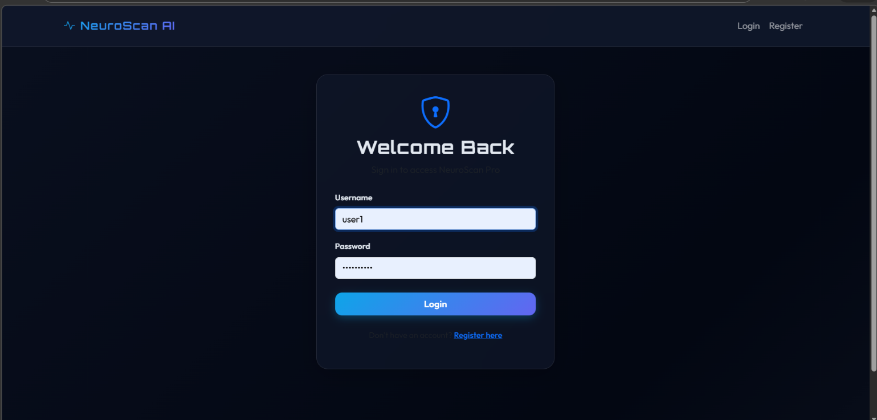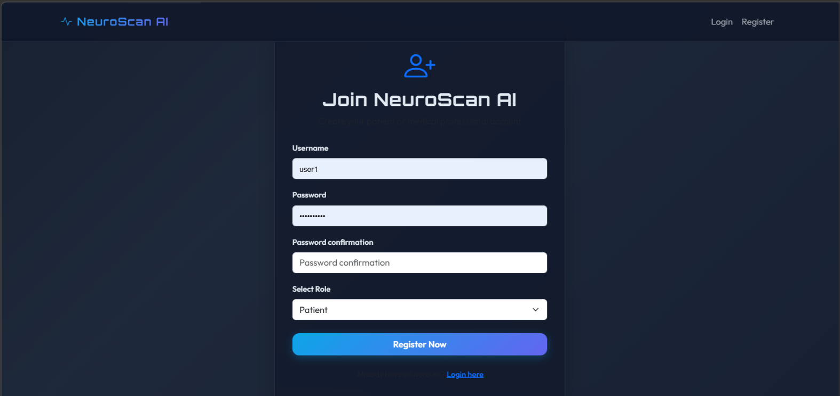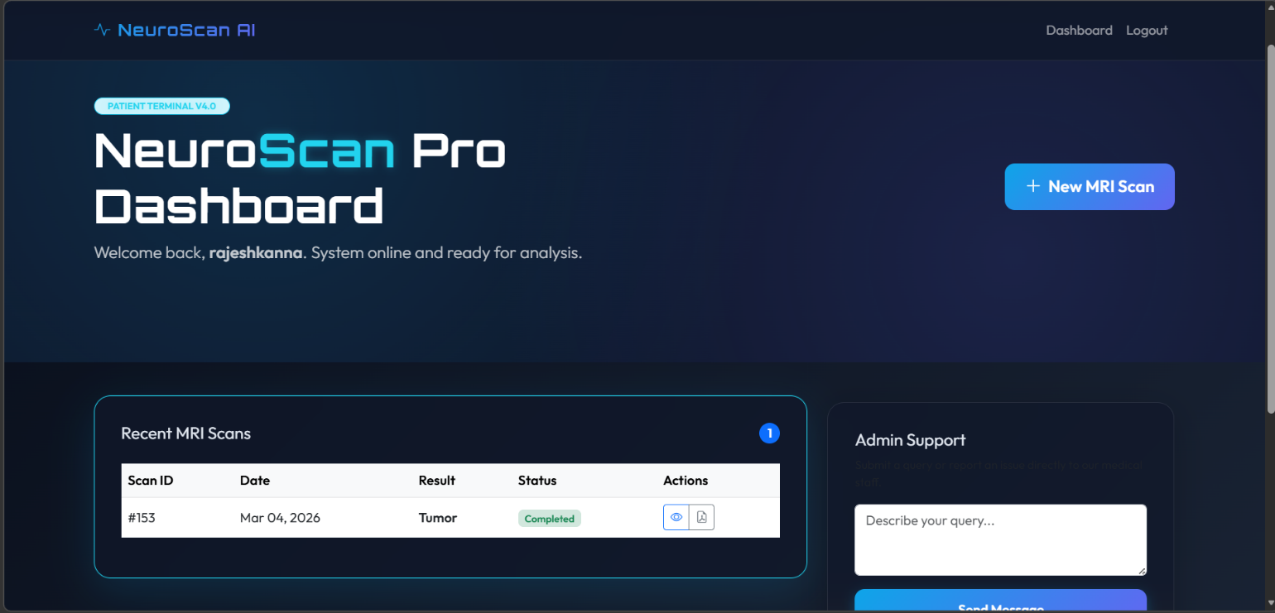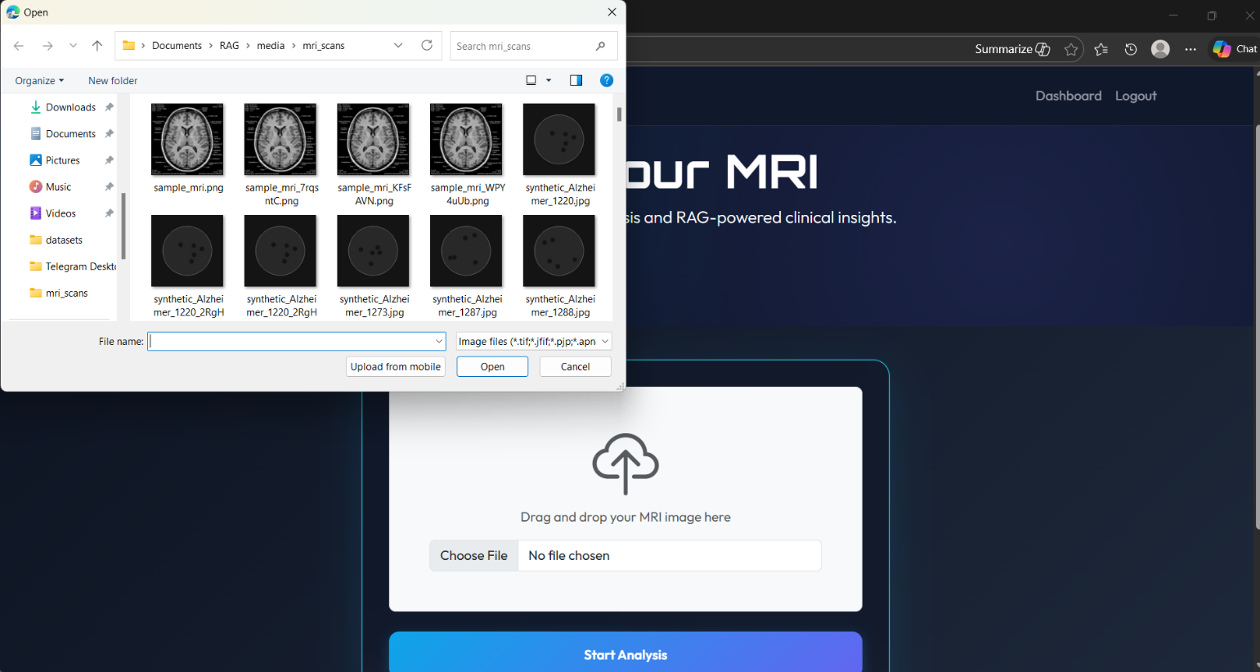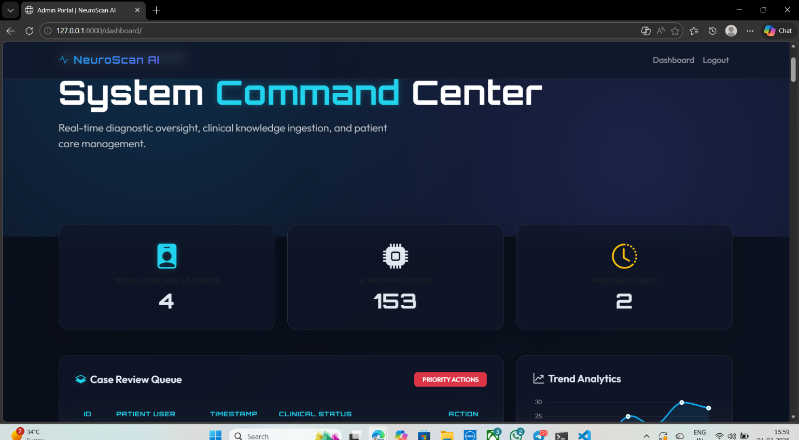

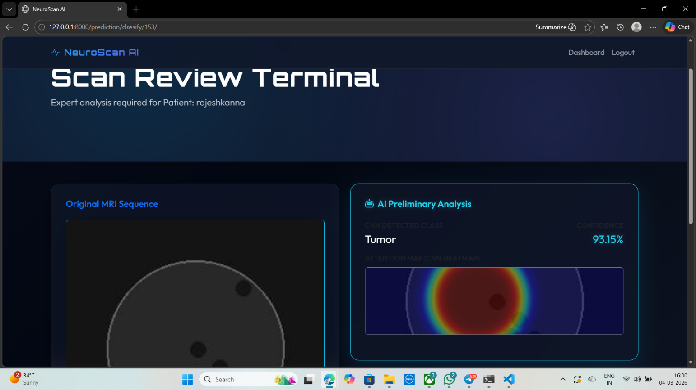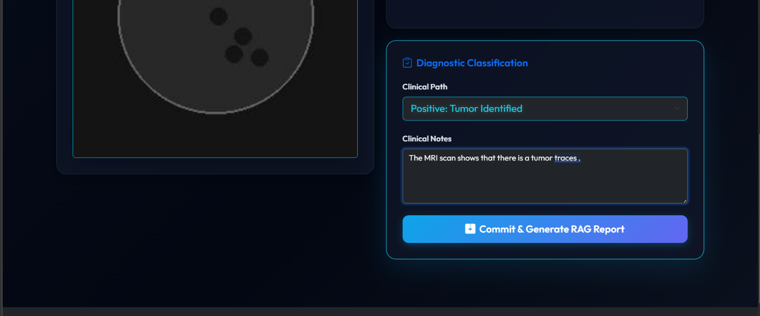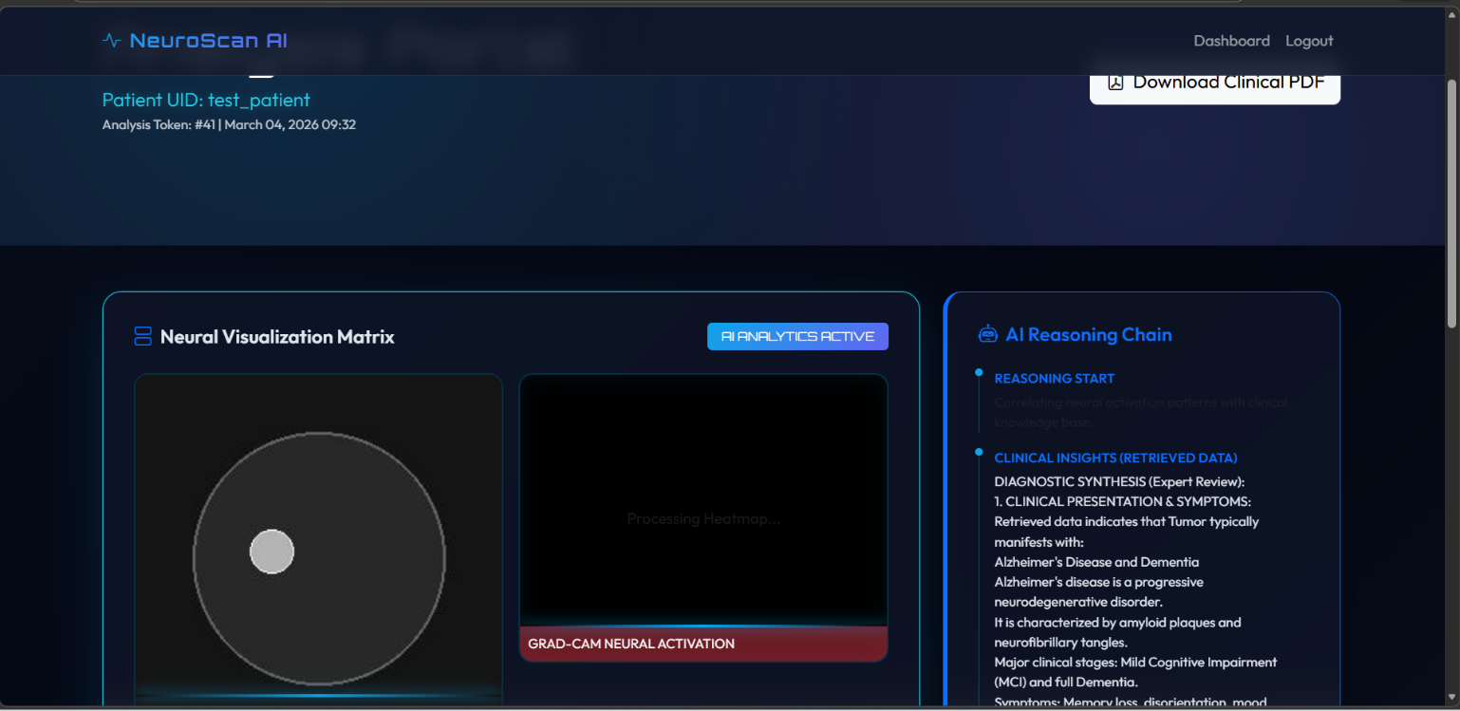

CHAPTER-11 CONCLUSION

CONCLUSION

This project presents NeuroScan AI, an intelligent system designed to assist in the detection of neurological conditions using brain MRI images. The main objective of the project is to develop an automated and user-friendly platform that can analyze MRI scans and classify them into Brain Tumor, Alzheimer’s Disease, and Normal Anatomy using deep learning techniques. By utilizing Convolutional Neural Networks (CNN), the system is capable of extracting important features from MRI images and providing accurate predictions that support medical diagnosis.
To improve the transparency of the predictions, the system integrates Explainable Artificial Intelligence techniques such as Grad-CAM, which highlights the regions of the brain MRI that influence the model’s decision. This helps clinicians understand the reasoning behind the prediction and increases trust in the AI system. Additionally, the platform includes a Retrieval-Augmented Generation (RAG) module that provides relevant clinical insights related to the predicted condition, supporting doctors in their diagnostic process.
The system is implemented using the Django web framework, allowing users to upload MRI images, view predictions, and access results through a secure web interface. The platform includes user authentication, patient dashboards, and expert review functionalities to ensure practical usability in healthcare environments.
Overall, the proposed system demonstrates how deep learning, explainable AI, and web technologies can be integrated to build an intelligent healthcare solution. NeuroScan AI has the potential to assist medical professionals in diagnosing neurological disorders more efficiently, reducing manual workload and improving the accuracy and speed of medical analysis.
.

CHAPTER-12 REFERENCES
[1] S. Pereira, A. Pinto, V. Alves and C. A. Silva, "Brain Tumor Segmentation Using Convolutional Neural Networks in MRI Images," IEEE Transactions on Medical Imaging, Vol. 35, No. 5, pp. 1240–1251, May 2016.
[2] O. Russakovsky, J. Deng, H. Su, J. Krause, S. Satheesh and A. Karpathy, "ImageNet Large Scale Visual Recognition Challenge," International Journal of Computer Vision, Vol. 115, No. 3, pp. 211–252, December 2015.
[3] K. He, X. Zhang, S. Ren and J. Sun, "Deep Residual Learning for Image Recognition," 2016 IEEE Conference on Computer Vision and Pattern Recognition (CVPR), 2016, pp. 770–778.
[4] A. Krizhevsky, I. Sutskever and G. E. Hinton, "ImageNet Classification with Deep Convolutional Neural Networks," Advances in Neural Information Processing Systems (NIPS), Vol. 25, pp. 1097–1105, 2012.
[5] R. R. Selvaraju, M. Cogswell, A. Das, R. Vedantam, D. Parikh and D. Batra, "Grad-CAM: Visual Explanations from Deep Networks via Gradient-Based Localization," 2017 IEEE International Conference on Computer Vision (ICCV), pp. 618–626, 2017.
[6] A. Esteva, B. Kuprel, R. A. Novoa, J. Ko, S. M. Swetter and H. M. Blau, "Dermatologist-Level Classification of Skin Cancer with Deep Neural Networks," Nature, Vol. 542, No. 7639, pp. 115–118, February 2017.
[7] D. Shen, G. Wu and H. Suk, "Deep Learning in Medical Image Analysis," Annual Review of Biomedical Engineering, Vol. 19, pp. 221–248, June 2017.
[8] T. Mikolov, K. Chen, G. Corrado and J. Dean, "Efficient Estimation of Word Representations in Vector Space," Proceedings of the International Conference on Learning Representations (ICLR), 2013.
[9] L. Perez and J. Wang, "The Effectiveness of Data Augmentation in Image Classification Using Deep Learning," arXiv preprint arXiv:1712.04621, 2017.
[10] I. Goodfellow, Y. Bengio and A. Courville, "Deep Learning," MIT Press, Cambridge, Massachusetts, 2016.
[11] A. Géron, "Hands-On Machine Learning with Scikit-Learn, Keras, and TensorFlow," O’Reilly Media, 2019.
[12] J. Brownlee, "Deep Learning for Computer Vision: Image Classification, Object Detection and Face Recognition in Python," Machine Learning Mastery, 2019.
[13] A. Paszke, S. Gross, F. Massa, A. Lerer, J. Bradbury and G. Chanan, "PyTorch: An Imperative Style, High-Performance Deep Learning Library," Advances in Neural Information Processing Systems (NeurIPS), 2019.
[14] A. Vaswani, N. Shazeer, N. Parmar, J. Uszkoreit, L. Jones and A. Gomez, "Attention is All You Need," Advances in Neural Information Processing Systems (NIPS), 2017.
[15] A. Rosebrock, "Deep Learning for Computer Vision with Python," PyImageSearch Publications, 2019.
[16] D. Chollet, "Deep Learning with Python," Manning Publications, 2017.
.

